Get your hands on 4 great voting rules.  See fair-share tallies organize voters.  Vote fast on reps, budgets and policies.  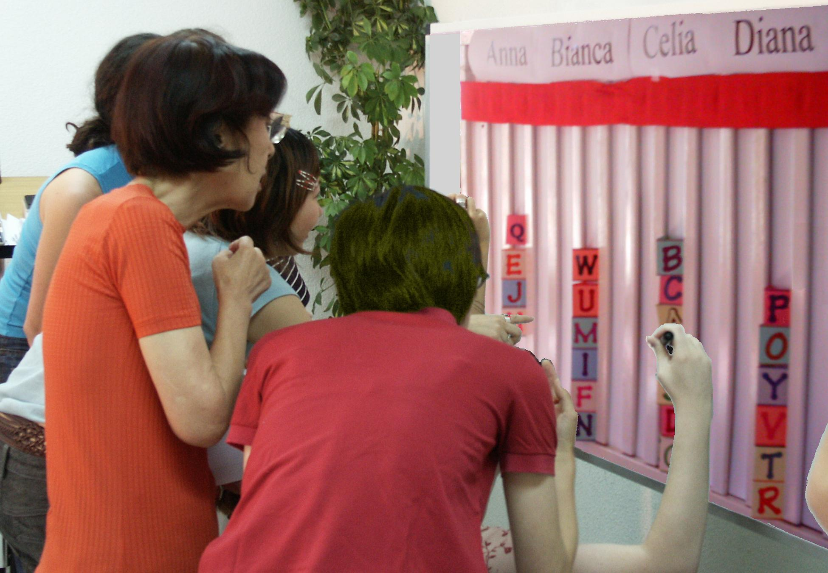  A Tally Board has   A card for each voter,  A column for each option,  A finish line for the favorites. |  | IRV elects leaders in San Francisco, Minneapolis...  It elects students at Duke, Rice, Reed, MIT, UCLA…  1. A card that moves is no bigger than any other: T, F  2. Your 2nd choice vote can’t hurt your 1st choice: T, F  3. Only one candidate can reach 50% + 1 vote: T, F  Movable Votes Electing Three Reps  To elect three reps by Single Transferable Vote   The finish line is set at 1/4 of the cards + 1.  Do not give a card to a candidate who has finished.  Eliminate the weakest candidates one at a time.  Move your cards until three candidates win!  Users include Australian and Irish voters, Princeton, Harvard, MIT, Oberlin, Berkeley, Oxford, Cambridge,  some unions and the Church of England.  It gives each group their fair share of seats.  Voters get more choices; so more turnout to vote.  It makes more effective votes that elect reps.  4. What total fraction must the three reps win?  5. Only three candidates can win 25% + 1 vote: T, F  Ask questions one and two with each voting rule.  Transparent, fair-share budget rules New! ➔
Instant Runoff Voting Elects One   A finish line marks the height of half the cards + 1.  That is how many votes a candidate needs to win.  Eliminate the weakest candidate if no one wins.  Draw names from a hat to break ties.  Move your card if your candidate loses.  This is your “movable vote”.  Repeat until one candidate reaches the finish line!  This chart shows four columns on a tally board.  The rule dropped Anna, so voter JJ moved his card.  Then Bianca lost, so BB and GG moved their cards.
  Anna  Eliminated 1st |  | Bianca  Eliminated 2nd
   |  | B B
  J J |  | G G
  Celia  IRV Winner |  | Diana  Runner up
  Finish Line__Finish Line__Finish
  B B
  J J |  | G G
  M M |  | Z Z
  L L |  | D D
  C C |  | V V

Fair-Share Spending Picks Projects   Let's say we each put in $1 to buy some items.  You get two 25¢ voting cards and a 50¢ card.  We say an item needs modest support from 8 of  us to prove it is a public good worth public money.  So the finish line marks the height of 8 cards.  You may put only one of your cards in a column.  So you can't dump all your cards on a private item.  Tip: Give your double card to your favorite.  This way 4 eager voters can fund a low-cost item.  A costly item must fill several columns. A column  here holds $2, so a $4 item must fill 2 columns.  When an item wins, the treasurer hides its cards. We drop any that cost more than all the cards left.  Then we drop the one furthest from winning, with the smallest fraction of its columns filled.  Move your card from a loser to your next choice.  Tip: You may save a threatened favorite by briefly withholding your cards from lower-choice items.  We stop when all items still on the board are paid.  Only a few items can win, but all voters can win! | $  $  $ | …and Set Budgets  Each funding level is like another project.  It needs enough cards to fill it up.  The “$4 carton of OJ” has two columns.  The “$6 bottle of OJ” adds just one more column.  A supporter must help fill the lower level first.  One at a time, the weak levels lose and the money  moves  to help favorites still in the running.  6. Should we let each member fund private items?  7. Should a member who pays more taxes or dues get more power to spend the group's money?  8. Should voters see grants by a rep? (or a voter?)  9. Who could use Fair-share Spending? IRV? STV?  Each funding level of an agency is another project.  But an agency starts with about 80% of its old budget.  So a voter cannot give it zero and steal a “free ride.”  Movable votes are often called transferable votes.  A finish line is a winning threshold or a quota of votes.  Answers: 1 True, 2 True, 3 True; 4 3/4 + 3 votes, 5 T;  6 no, 7 no, 8 yes (no), 9 many; 10 center, 11 yes.
Today’s hottest reforms are Ranked-Choice Voting
and Participatory Budgeting with Fair-share Spending.
Condorcet Centers a Policy   The winner must top each rival, one-against-one.  Put flag C at our center, by the median voter.  Make 3 flags surround C, each about 5' from it.  Ask: “Are you closer to flag A than to B? If so, please raise a hand.” Then test A against C, etc.  Put each total in this Condorcet pairwise table.  Flag C has a 3' Red ribbon and a long Blue one.  If the Red ribbon gets to you, the Red policy gets  your vote with its narrow appeal.  If the Red cannot touch you, the wide appeal  of the Blue policy gets your vote. Which one wins?  If the flags are places for a heater in an icy cold room  10. Do we put it at our center or in the biggest group?  11. Do we turn on its fan to spread the heat wide? | ❶  ❷  ❸ | Ranked-Choice Ballots  Only a small group can crowd around a tally board.  Big groups use paper ballots, tallied by computer.  Check-mark ballots badly oversimplify most issues. Such limited choices tend to polarize voters to see an issue as “us versus them” or “left versus right”.  Ranked-choice ballots cut those negative results.  They let you rank your favorite and a backup or two.  Ranks can reveal a great variety of opinions. Polls show most voters like the power to rank candidates.  ...These rules strengthen votes and thus mandates. They organize voters and lift the number supporting  a Chairperson from a plurality to a majority,  a Council from a plurality to over three quarters,  a Budget from a few power blocs to all members,  a Policy from a one-sided to an over-all majority.  Learn more at AccurateDemocracy.com.  Then build support in your school, club or town with FairVote, The Center for Voting and Democracy  © CC BY-SA 2014, Robert Loring
  against | A | B | C | D
  for A | — | 2 | 2 | 3
  for B | 5 | — | 2 | 3
  for C | 5 | 5 | — | 4
  for D | 4 | 4 | 3 | —

