Get your hands on 4 great voting rules.  See fair-share tallies organize voters.  Vote fast on reps, budgets and policies.  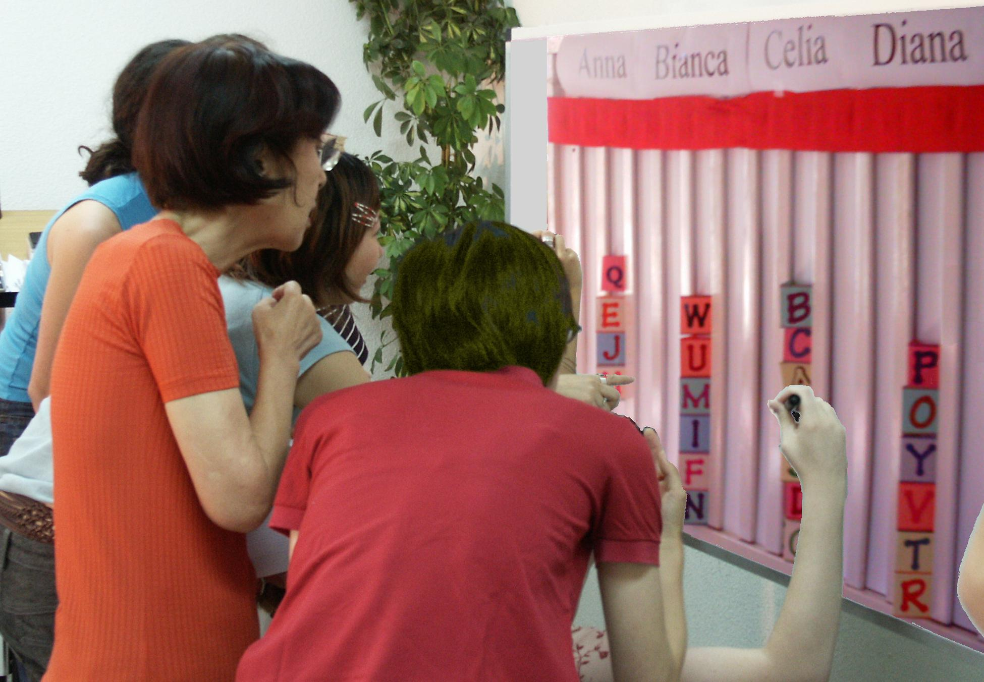  A Tally Board has   A card for each voter,  A column for each option,  A finish line for the favorites. 37 |  | IRV elects leaders in San Francisco, Minneapolis...  It elects students at Duke, Rice, Reed, MIT, UCLA…  1. A card that moves counts just like others: T, F  2. Ranking your 2nd choice can’t hurt your 1st: T, F  3. Only one candidate can reach 50% + a vote: T, F  Movable Votes Electing 3 Reps  To elect three reps by Single Transferable Vote   The finish line is set at 1/4 of the cards plus one.  Don't put your card in a column that is full.  Drop the weakest candidates one at a time.  Move the cards until three candidates win!  Users include Australian and Irish voters, Harvard, MIT, Oberlin, Berkeley, Davis, Oxford, Cambridge, some unions and the Church of England.  It gives each group their fair share of seats, so  voters get real choices; so more turnout to vote.  It makes more effective votes that elect reps.  4. What total fraction must the three reps win?  5. Only three candidates can win 25% + 1 vote: T, F  Ask questions one and two with each voting rule.  Transparent, fair-share budget rules New! ➔
Instant Runoff Voting Elects One   A finish line marks the height of half the cards + 1.  That is how many votes a candidate needs to win.  Eliminate the weakest candidate if no one wins.  Draw names from a hat to break ties.  Move your card if your candidate loses.  This is your movable or “transferable vote”.  Repeat until one candidate reaches the finish line!  This chart shows four columns on a tally board.  The rule dropped Anna, so voter JJ moved his card.  Then Bianca lost, so BB and GG moved their cards. | 38
  Anna  Eliminated 1st |  | Bianca  Dropped 2nd
   |  | B B
  J J |  | G G
  Celia  IRV Winner |  | Diana  Runner up
  Finish Line__Finish Line__Finish
  B B
  J J |  | G G
  M M |  | Z Z
  L L |  | D D
  C C |  | V V

Fair Share Voting Picks Goods   Let's say we each put in $1 to buy some items. You get two 25¢ voting cards and a 50¢ card.  We say an item needs modest support from 8 of us to prove it is a public good worth public money. So the finish line marks the height of 8 cards.  You may put only one of your cards in a column. So you can't dump all your cards on a private item. Tip: Give your double card to your favorite. This way 4 eager voters can fund a low-cost item.  A costly item must fill several columns. A column here holds $2, so a $4 item must fill 2 columns.  When an item wins, the treasurer hides its cards. We drop any that cost more than all the cards left.  Then we drop the one furthest from winning, with the smallest fraction of its columns filled.  Move your card from a loser to your next choice. Tip: You may save a threatened favorite by briefly withholding your cards from lower-choice items.  We stop when all items still on the board are paid. Only a few items can win, but all voters can win! 41 | $  $  $ | …and Sets Their Budgets  Each funding level is like another project. It needs enough cards to fill it up.  The “$4 carton of OJ” has two columns. The “$6 bottle of OJ” adds just one more column. A supporter must help fill the lower level first.  The item with the weakest top level loses it. Voters move their cards from it to items still on the board. Soon, all remaining budget levels are fully funded.  The trick with treats is to split the biggest group so they lose by plurality. Less popular treats win. We use many flavors of chocolate-chip cookies: soft and crisp, dark and milk, nuts and no nuts; or an array of potato and corn chips and crackers for dips.  Before votes transfer, the chips all lose, or at least show many wasted votes. The healthy apples win!  6. Should we let each member fund private items?  7. Should a member who pays more taxes or dues get more power to spend the group's money?  8. Should voters see grants by a rep? (or a voter?)  9. Who could use Fair Share Voting? IRV? STV?  42
Today’s hottest reforms are Ranked-Choice Voting
and Participatory Budgeting with Fair Share Voting.
Condorcet Centers a Policy   The winner must top each rival, one-against-one.  Put flag C at our center, by the median voter.  Make 3 flags surround C, each about 5' from it.  Ask: “Are you closer to flag A than to B? If so, please raise a hand.” Then test A against C, etc.  Put each total in this Condorcet pairwise table.  Flag C has a 3' Red ribbon and a long Blue one.  If the Red ribbon gets to you, the Red policy gets  your vote with its narrow appeal.  If the Red cannot touch you, the wide appeal  of the Blue policy gets your vote. Which one wins?  If the flags are places for a heater in an icy cold room  10. Do we put it at our center or in the biggest group?  11. Do we turn on its fan to spread the heat wide? 43 |      | Workshop Suggestions  A hands-on game for loot to share makes memories more vivid and lasting than a lecture or homework.  We can vote for a party menu, a dance play list, a ... Caution: long ballots lead some voters to give up. Great ballot design cuts voter errors and exhaustion.  Accuratedemocracy.com/a_workshop.htm has more complete answers, so does /a_primer.htm. Go to /a_teach.htm for handouts, ballots and voting cards.  Enjoy the treats while discussing how FSV helps a group pick: projects, playlists, investments or __.  Answers and Essays  IRV 1 True, in each round of counting it is 1 vote.  2 True, doesn't count until the 1st has lost. 3 true;  STV 4 3/4 + 3 votes, 5 True, more would need >100%. Fair Share Voting 6 no, 7 no, 8 yes (no), 9 many; Condorcet 10 Center of all voters, 11 Probably yes.  Plan how to tally fair shares or a central majority for a group you know well. Use terms from the glossary.  What qualities do you want in a group tally?  Empowering, fair and easy for voters, i.e. strategy free.  45
  against | A | B | C | D
  for A | — | 2 | 2 | 3
  for B | 5 | — | 2 | 3
  for C | 5 | 5 | — | 4
  for D | 4 | 4 | 3 | —

