Full-Choice Ballots  Only small groups can crowd around a tally board.  Big groups use paper ballots, tallied by computer.  Old-fashioned ballots oversimplify most issues. They let you mark only one option “yes”, leaving all others “no”. This creates false dichotomies, limited choices that polarize voters and increase conflict.  Full-choice ballots cut those negative results.  They let you rank a 1st choice, 2nd choice, 3rd etc.  Ranks reveal the labels, “us versus them” or left  versus right, hide moderate points of view.  These rules strengthen votes and thus mandates. They organize voters and lift the number supporting:   a Chairperson from a plurality to a majority,   a Council from a plurality to over three quarters,   a Budget from a few blocs to all members,  a Policy from a 1-sided to an over-all majority.  Learn more at AccurateDemocracy.com.  Then build support in your school, club or town with FairVote, The Center for Voting and Democracy |  | Get your hands on 5 great voting rules.  See fair-share tallies organize voters.  Vote fast on budgets, rules and projects.  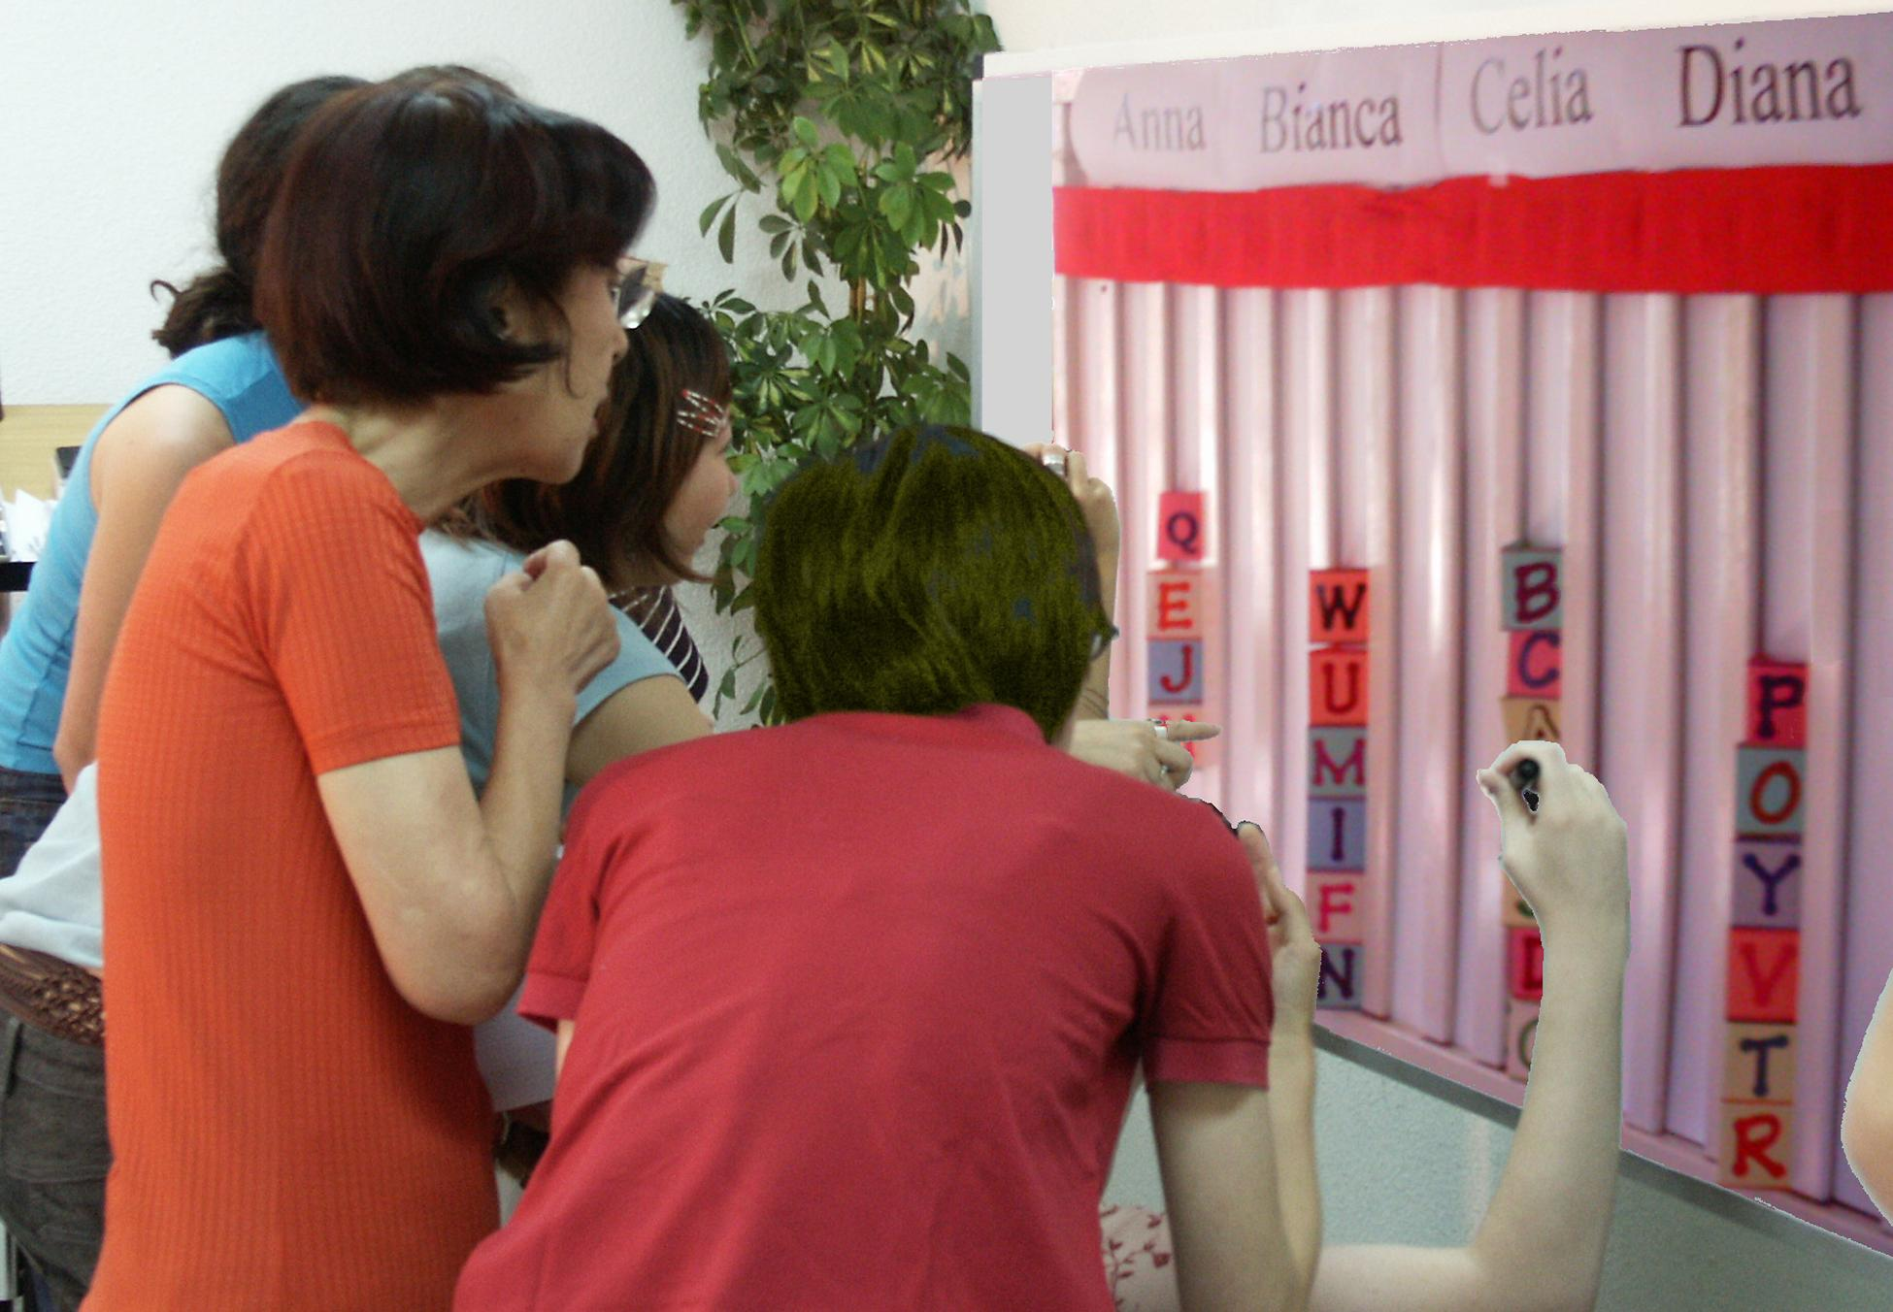  A tally board has   A card for each voter,  A column for each option,  A finish line for the favorites. |  | Instant Runoff Voting Elects 1 Winner   A finish line marks the height of half the cards+1  That is how many votes a candidate needs to win.  Eliminate the weakest candidate if no one wins.  Draw names from a hat to break ties.  Move your card if your candidate loses.  Repeat until one candidate gets the finish line!  This chart shows four columns on a tally board.  The rule dropped Anna, so voter JJ moved.  Then Bianca lost, so BB and GG moved.
  Anna  Eliminated 1st |  | Bianca  Eliminated 2nd
   |  | B B
  J J |  | G G
  Celia  IRV Winner |  | Diana  Runner up
  Finish_Line |  | Finish_Line
  B B
  J J |  | G G
  T T |  | Z Z
  K K |  | D D
  C C |  | V V
Instant Runoff Voting cont.  By organizing voters, Instant Runoffs avoid:  Spoilers and the lesser-of-two-evils choice;  Costly runoffs and winners-without-mandates.  IRV elects leaders in San Francisco, Burlington...  It elects students at Duke, Rice, Reed, MIT, UCLA...  1. A card that moves is no bigger than any other: T, F  2. Your 2nd choice vote can’t hurt your 1st choice: T, F  3. Only one candidate can reach 50% + 1 vote: T, F  Electing 3 Reps by Choice Voting (CV)  The finish line is set at 1/4 of the cards + one.  Give no cards to a candidate who has finished.  Eliminate the weakest candidates one at a time.  Move your cards until three candidates win!  CV is used in Australian and Irish elections, at Princeton, Harvard, Berkeley, Oxford, Cambridge,  in some labor unions and the Church of England.  CV gives each group their fair share of seats.  Voters get more choices; so more turnout to vote.  It makes more votes effective at electing reps.  4. What total fraction must three CV reps win? | . | Movable Money Votes Buy Public Goods  Let's say we each put in $1 to buy some items.  You get two 25¢ voting cards and a 50¢ card.  We say an item needs modest support from 8 of  us to prove it’s a public good worth public money.  So the finish line marks the height of 8 cards.  You may put only one of your cards in a column.  So you can't dump all your cards on a private item.  Tip: Give your double card to your favorite.  This way 4 eager voters can fund a low-cost item.  A costly item must fill several columns.  Each holds $2, so a $4 item must fill two columns.  When an item wins, the banker hides its cards.  We drop an item if it costs more than all cards left.  Then 1 at a time, we drop the least popular item,  with the lowest level of cards in its columns.  Move your card from a loser to your next choice.  Tip: You may save a threatened favorite by briefly withholding your cards from lower-choice items.  We stop when all items still on the table are paid.  Only a few items can win, but all voters can win! |  | ... and Set Budgets  Each funding level is like another project.  It needs enough cards to fill it up.  The column for “$3 OJ” starts at the bottom.  Its finish line is at the tally board's $3 level.  The column for “$5 OJ” is blocked off up to $3. Its finish line is at $5; so it needs only $2 in cards.  A supporter must put a card in the lower level first.  One at a time, the weak ones lose and money  moves – to help favorites still in the running.  5. Should we let a member fund private items?  6. Should people who pay more taxes or dues get more power to spend public money?  7. Should voters see grants by a rep? (or voter?)  8. Who could use Fair-share Spending?  (Each funding level of an agency is another project.  But an agency starts with about 80% of its old budget.  So a voter cannot give it nothing and “take a free ride.”)  Answers: IRV: T, T, T. Choice Voting: 3/4 + 3 votes.  Spending: no, no, yes (no), many. Pairwise: mid, yes.  © 2009, Robert Loring, VotingSite@aol.com | . | Pairwise Tally Centers a Policy  Flag C is at our center, by the median voter.  Three flags surround C, about 5' from it.  We ask, “Are you closer to flag A than flag B?  If so, raise your hand.” Then A against C, etc.  We put each total in the Pairwise table below.  The winner must top every rival, 1-against-1.  A pole stands at our center, by the median voter.  It holds a short Red ribbon and a long Blue one.  If the Red ribbon gets to you, the Red policy gets  your vote with its narrow appeal.  But if the Red cannot touch you, the wide appeal  of the Blue policy gets your vote. Which 1 wins?  If poles are spots for a heater in a cold room:  6. Do we put it at our center or in the biggest group?  7. Do we turn on its fan to spread its heat wide?
  against | A | B | C | D
  for A | — | 2 | 2 | 3
  for B | 5 | — | 2 | 3
  for C | 5 | 5 | — | 4
  for D | 4 | 4 | 3 | —

