Movable Votes

Get your hands on 5 great voting rules.
See fair-share tallies organize voters.
Vote fast on budgets, policies and projects.

5 Great Voting Rules:
 Instant Runoff Voting elects a strong executive.
 Single Transferable Vote Elects a whole council.
 Movable Money Votes select projects.
 Budget Refill Voting funds many departments.
 Pairwise Voting centers policy – bonus rule.

See Two Key Ideas:

 A Movable Vote,
A Winning Number of Votes.

Voters Moving Their Chips

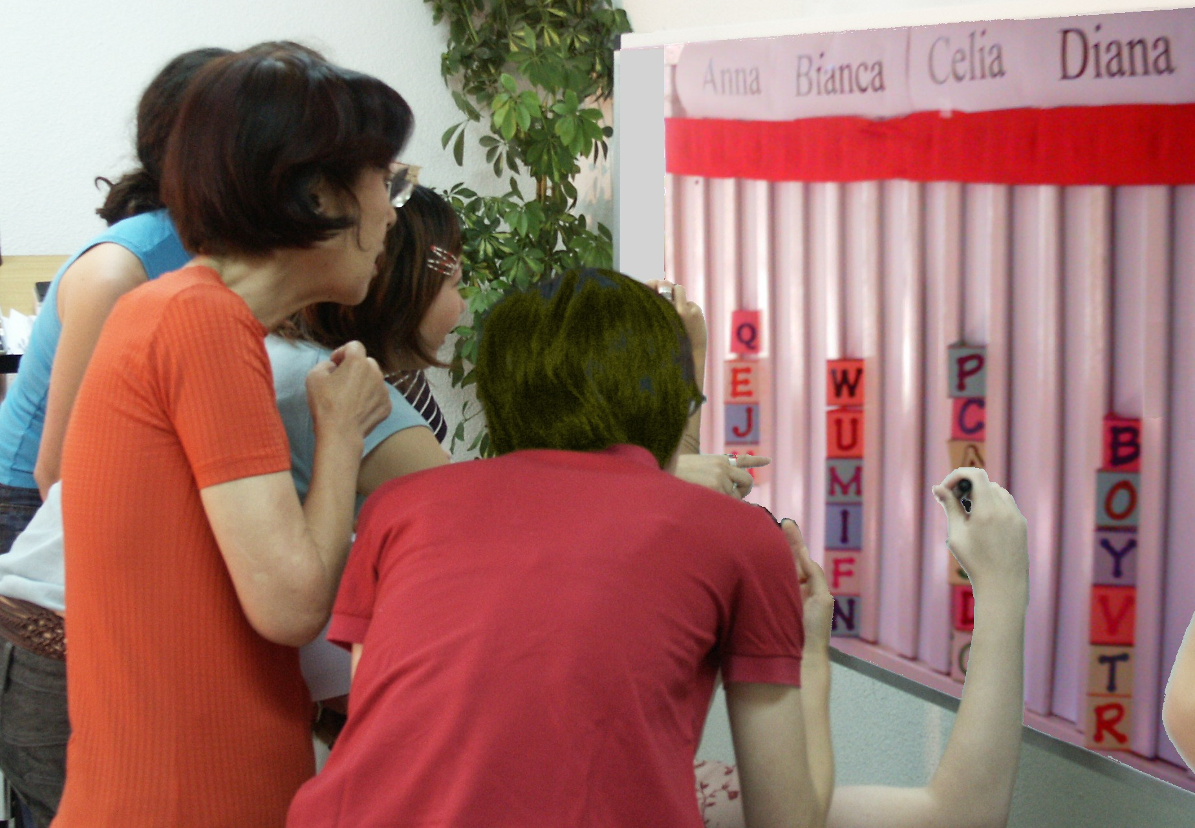

A tally board has:
A chip for each voter,
A column for each option,
A finish line for the favorites.

Chips Tally IRV Election |  | Anna  Eliminated 1st |  | Bianca  Eliminated 2nd |  | Celia  Runner up |  | Diana  IRV Winner
 |  | Finish Line |  | Finish Line |  | Finish Line |  | Finish Line
1. The weakest candidate, Anna, was eliminated. |  |  |  | 2. Then Barbara was eliminated. |  | B B |  | 2. Then Barbara was eliminated.
2. So voter JJ, moved his chip. |  | So the voter DD, moved her chip. |  | So GG and JJ moved their chips. |  | J J |  | G G
3. Then Bianca was eliminated. |  |  |  | Gigi moves  her chip. |  | T T |  | Z Z
4. So BB and GG moved their chips. |  |  |  | B B |  | K K |  | D D
5. Five voters lift Celia to the finish line! |  | J J |  | G G |  | C C |  | V V

IRV Elects One Winner.
For a one-seat election by Instant Runoff Voting:
The finish line marks the height of half the chips +1.
This is the “winning number of votes”.
Eliminate the weakest candidate if no one wins.
Draw names from a hat to break ties.
Move your chip if your candidate loses.
This is a “movable vote”.
Repeat until one candidate reaches the finish line! 11

IRV Is Used Here:
IRV elects the president of Ireland, and the mayors of Dublin, London, Sidney and most Australian cities.
In the USA, San Francisco, Burlington, and Takoma Park recently adopted IRV.
IRV elects student leaders at more and more U.S. colleges and universities including: Duke, Harvard, Stanford, Rice, Tufts, MIT, Cal Tech, Carlton, Clark, Hendrix, Reed, Vassar, Whitman, Wm & Mary,
The University of: CA, IL, MD, MN, OK, VA, WA…

IRV Benefits:
A majority winner from 1 election, so no winners-without-mandates and no costly runoff elections.
Less negative campaigning, as a candidate must ask a rival's supporters for their 2nd choice votes.
No hurting your first choice by ranking a 2nd, as a 2nd does not count unless the 1st choice has lost.
No lesser-of-two-evils choice, as the voter can mark his true 1st choice without fear of wasting his vote.
No spoilers, as votes for minor candidates move to each voter's more popular choices. 13

IRV Questions:
1. How can your group use Instant Runoff Voting?
2. Is a moved vote bigger than other votes? Does
its voter have more chips or power than other voters?
3. Your 2nd choice vote can’t hurt your 1st choice: T, F
4. Only one candidate can reach 50% + 1 vote: T, F
14

STV Elects a Council.
In a three-seat election by Single Transferable Vote:
The finish line's height is 1/4 of the chips +1.
Do not give chips to a candidate who has won.
Eliminate the weakest candidates one at a time.
Voters move their chips until three candidates win! 21

STV Is Used Here:
STV elects national legislatures or city councils in Australian, Ireland, Malta New Zealand, and Scotland.
STV elects some union and church councils in Australia and England.
STV elects student councils at UC Berkeley, UC Davis, Harvard, Princeton, Vassar, and Whitman. Oxford, Cambridge and many other British and Australian Universities also use STV. 22

STV Benefits:
It increases choices for voters and turnout of voters,
It elects more women and minorities candidates.
It gives each group their fair share of council seats.
It increases conformity of policies to public opinions.
It increases funding for health and education. 23

STV Questions:
1. Can four candidates each win 25% + 1 vote?
2. What total percent must three STV reps win?
3. What is the percent needed to win one of five seats?
4. Can your second choice hurt your first choice?
5. How could you use the Single Transferable Vote? 24

MMV Buys Public Goods.
For fair-share spending by Movable Money Votes:
Let's say we each put in $1 to buy some items.
And the voting chips are worth $0.25 each.
You get two 25¢ voting chips and a 50¢ chip.
We say an item needs modest support from 8 of us
to prove it is a public good worth public money.
So the finish line marks the height of 8 chips. 31

MMV Selects Projects.
A costly item must fill several columns. A column
here is $2, so a $4 item must fill 2 columns.
You may put only one of your chips in a column.
So you can't dump all your chips on a private item.
And the winning share is 8 moderate backers.
Tip: Give your double chip to your favorite treat.
This way 4 eager voters can fund a low-cost treat.
The voters’ number and zeal both count. 32

Everyone Wins Something.
When an item wins, the banker hides its chips. We drop any item that costs more than all the chips left.
Then one at a time, we drop the least popular item, with the lowest level of chips in its columns.
Move your chip from a loser to your next choice.
Tip: Try to save a threatened favorite by briefly withholding your chips from lower-choice treats.
We stop when all items still on the table are paid up.
Only a few items can win, but all voters win items ! 33

MMV Questions:
1. Can your second choice hurt your first choice?
2. Should we let each voter or rep fund private items?
3. Should people who pay more taxes get more power
to spend public money? to set public laws?
4. How could your groups use MMV? 34

BRV Adjusts Departments.
In Budget Refill Voting for agencies or departments:
A big department has several columns to fill.
The columns each need $100... for the department
to reach last year’s budget; that's its refill line.
A supporter’s chips help refill a budget column.
Voters can push it above its goal line.
But its gain will be another program's loss. 41

BRV Sets Many Budgets.
Let's say a council of 20 decides each program needs modest support from 10 members to restore its funding.
So a column needs 10 chips from 10 voters to reach its refill line, or as few as 5 double chips from eager voters.
The group wants to budget 4 low-cost activities with 1 column each, plus 3 costly programs with 2 columns each. Those 10 columns X 10 chips to refill each = 100 chips.
The 100 chips / 20 voters = 5 chips for each voter; that's 1 double and 3 singles. You may put only 1 in a column. 42

BRV Balances Power.
Set target budgets and rank your priorities.
If a budget goes over your target, its priority drops.
So move your chips to your under-funded priorities.
Reacting is key!
We stop BRV when a hidden timer sounds.
You lose chips that are not on the board.
This deters faking votes until a last-moment switch.
A two-thirds majority may reopen the voting. 43

BRV Questions:
1. Does each voter control movable money?
2. Do programs need a winning number of votes?
3. Can your second choice hurt your first choice?
4. Should a rep’s chips be so visible to voters?
5. Who could use Budget Refill Voting?
Try it; it’s fast! 44

Pairwise Centers Policy.
Flag C stands at our center, by the median voter.
Three flags surround C, about 5' from it.
Pairwise asks: “Are you closer to flag A than B?
If so, please raise your hand. ” Then A against C, etc.
We put each total in the Pairwise table below.
The winner must beat every rival, one-against-one.
51

Pairwise Centers Policy.

against | A | B | C | D
for A | — | 2 | 2 | 3
for B | 5 | — | 2 | 3
for C | 5 | 5 | — | 4
for D | 4 | 4 | 3 | —
52

Pairwise Expands Appeal.
A pole stands at our center near the median voters.
It holds a short Red ribbon and a long Blue one.
If the Red ribbon gets to you, the Red policy gets
your vote with its narrow appeal.
But if the Red cannot touch you, the wide appeal
of the Blue policy gets your vote. Which one wins?
If the poles are places for a heater in an icy cold room:
A) Do we put it at the center or in the biggest group?
B) Do we turn on its fan to spread the heat wide? 53

Pairwise or IRV?
IRV asks, “Raise your hand if you are closer to A
than to any other flag. ” List the totals on the board.
If a flag gets over half the votes, it wins.
If no one wins, drop the flag with the fewest votes.
Ask people to vote for the closest remaining policy.
Compare winners: “Raise your hand if you are
closer to the Pairwise winner than to the IRV winner. ” 52

Pairwise Questions:
1. Can the middle voter enact any policy alone?
2. Can fringe voters affect a Pairwise tally?
3. Does Pairwise favor narrowly-centrist policies?
4. Should first-choice votes count more?
5. Does Pairwise set a “winning share”?
6. Do votes “move” from one choice to the next?
7. Where could you use Pairwise voting? 54

Full-Choice Ballots:
Only small groups can use chips for actual voting. Larger groups use paper ballots tallied by computer.
Old-fashioned ballots oversimplify most questions. They let us mark only one option “yes”, leaving all others “no”. This often promotes false dichotomies leading to social polarization and unnecessary conflict.
Full-choice ballots reduce those negative effects. They let a voter rank his 1st choice, 2nd choice, 3rd etc. Ranks often reveal the dichotomies, “us versus them” or left versus right, hide moderate points of view. 61

Vote Here:
Ties are allowed. Fill only one “O” on each line.
Ranks
Best Worst
Names | 1st | 2nd | 3rd | 4th | 5th | 6th
Perot | O | O | O | O | O | O
Clinton | O | O | O | O | O | O
Obama | O | O | O | O | O | O
Bush | O | O | O | O | O | O
McCain | O | O | O | O | O | O
Write In | O | O | O | O | O | O
62

Conclusions:
Movable votes are fast, easy and fair.
They organize powerful groups for popular choices.
They can select a committee, projects or budgets.
Politics is more principled with fair shares for reps
and money, full majorities for presidents and policies.

In Practice:
AccurateDemocracy.com has pages on the logic, uses and effects of voting rules, plus a teacher’s guide, printer-ready chips and software for anonymous voting.
For anonymity on a tabletop, put your ballot in a box
and pull out another voter’s, or a “mailed-in” ballot.
Only small groups can use tally boards for actual voting. Larger groups use paper ballots tallied by computer.

© 2003-2008, Robert Loring, Loring@AccurateDemocracy.com

