Get your hands on 5 great voting rules.  See fair-share tallies organize voters.  Vote fast on budgets, policies and projects.  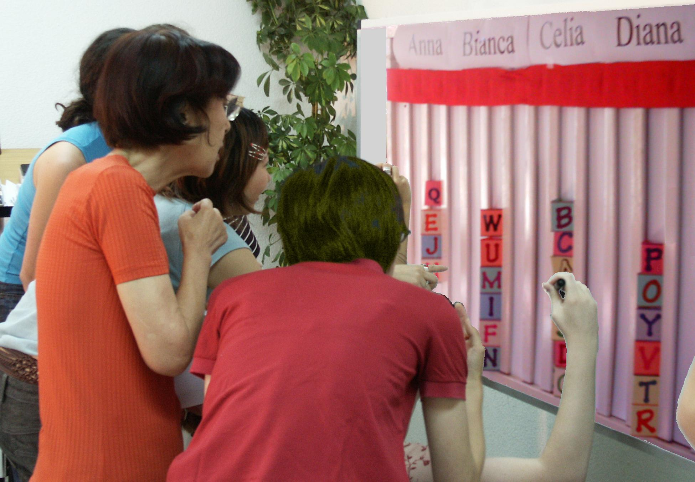  A Tally Board has   A card for each voter,  A column for each option,  A finish line for the favorites. |  | IRV elects leaders in San Francisco, Burlington...  It elects students at Duke, Rice, Reed, MIT, UCLA…  By organizing voters, Instant Runoffs avoid:  Spoilers and the lesser-of-two-evils choice;  Costly runoffs and winners-without-mandates.  1. A card that moves is no bigger than any other: T, F  2. Your 2nd choice vote can’t hurt your 1st choice: T, F  3. Only one candidate can reach 50% + 1 vote: T, F  Choice Voting Elects 3 Reps   The finish line is set at 1/4 of the cards plus one.  Do not give a card to a candidate who has finished.  Eliminate the weakest candidates one at a time.  Move your cards until three candidates win!  CV is used in Australian and Irish elections, at Princeton, Harvard, Berkeley, Oxford Cambridge,  in some unions and in the Church of England.  CV gives each group their fair share of seats.  Voters get more choices; so more turnout to vote.  It makes more effective votes that elect reps.  4. What total fraction must three CV reps win?  Transparent, fair-share budget rules New! ➔
Instant Runoff Voting Elects 1 Winner   A finish line marks the height of half the cards + 1.  That is how many votes a candidate needs to win.  Eliminate the weakest candidate if no one wins.  Draw names from a hat to break ties.  Move your card if your candidate loses.  This is your “movable vote”.  Repeat until one candidate reaches the finish line!  This chart shows four columns on a tally board.  The rule dropped Anna, so voter JJ moved.  Then Bianca lost, so BB and GG moved.
  Anna  Eliminated 1st |  | Bianca  Eliminated 2nd
   |  | B B
  J J |  | G G
  Celia  IRV Winner |  | Diana  Runner up
  Finish Line__Finish Line__Finish
  B B
  J J |  | G G
  T T |  | Z Z
  K K |  | D D
  C C |  | V V

 | Movable Money Votes Buy Public Goods   Let's say we each put in $1 to buy some items.  You get two 25¢ voting cards and a 50¢ card.  We say an item needs modest support from 8 of  us to prove it is a public good worth public money.  So the finish line marks the height of 8 cards.  You may put only 1 of your cards in a column.  So you can't dump all your cards on a private item.  Tip: Give your double card to your favorite.  This way 4 eager voters can fund a low-cost item.  A costly item must fill several columns. A column  here holds $2, so a $4 item must fill 2 columns.  When an item wins, the banker hides its cards. We  drop an item if it costs more than all the cards left.  Then 1 at a time, we drop the least popular item  with the lowest level of cards in its columns.  Move your card from a loser to your next choice.  Tip: You may save a threatened favorite by briefly withholding your cards from lower-choice items.  We stop when all items still on the board are paid.  Only a few items can win, but all voters can win!  Treat department funding levels as projects, or... | $  $  $ | Budget Refill Votes Adjust Departments   A big department has several columns to fill.  The columns each need $100... for the dept. to reach last year’s budget; that's its refill line.  A supporter’s cards help refill its budget columns.  Voters can push it above its refill line.  But its gain will be another department's loss.  Let's say a council of 20 decides each dept. needs  modest support from 10 voters to restore its funding.  So a column needs 10 cards from 10 voters to reach  its refill line, or 5 double cards from eager voters.  The group wants to budget 4 low-cost activities with  1 column each, plus 3 costly programs of 2 columns.  The 10 columns X 10 cards to refill each = 100 cards.  The 100 cards / 20 voters = 5 cards for a voter; that's 1 double and 3 singles. Put just 1 in a column.  Set target budgets and rank your priorities.  If a budget goes too high, its priority drops.  So move your cards to under-funded priorities.  We stop voting when a hidden timer sounds.  This deters faking votes until a last-minute switch.  A supermajority may reopen the voting.
From today’s hottest reform, Instant Runoff Voting,
to the cutting edge in transparent, fair-share budget rules...
 | Pairwise Centers a Policy   Flag C stands at our center, by the median voter.  Three flags surround C, about 5' from it.  Pairwise asks: “Are you closer to flag A than B?  If so, please raise 1 hand.” Then A against C, etc.  We put each total in the Pairwise table below.  The winner must top every rival, 1-against-1.  A pole stands at our center, by the median voter.  It holds a short Red ribbon and a long Blue one.  If the Red ribbon gets to you, the Red policy gets  your vote with its narrow appeal.  If the Red cannot touch you, the wide appeal  of the Blue policy gets your vote. Which 1 wins?  If the flags are places for a heater in an icy cold room:  5. Do we put it at our middle or in the biggest group?  6. Do we turn on its fan to spread the heat wide? | ❶  ❷  ❸ | Full-Choice Ballots  Only a small group can crowd around a tally board.  Big groups use paper ballots, tallied by computer.  Old-fashioned ballots oversimplify most issues. They let you mark only one option “yes”, leaving all others “no”. This creates false dichotomies, limited choices that polarize voters and increase conflict.  Full-choice ballots cut those negative results.  They let you rank a 1st choice, 2nd choice, 3rd etc.  Ranks reveal the labels, “us versus them” or left  versus right, hide moderate points of view.  ...These rules strengthen votes and thus mandates. They organize voters and lift the number supporting  a Chairperson from a plurality to a majority,  a Council from a plurality to over three quarters,  a Budget from a few power blocs to all members  a Policy from a one-sided to an over-all majority.  Learn more at AccurateDemocracy.com.  Then build support in your school, club or town with FairVote, The Center for Voting and Democracy  Answers: IRV: T, T, T. STV: 3/4. Pairwise: mid, yes.  © 2008, Robert Loring, VotingSite@aol.com
  against | A | B | C | D
  for A | — | 2 | 2 | 3
  for B | 5 | — | 2 | 3
  for C | 5 | 5 | — | 4
  for D | 4 | 4 | 3 | —

