Get your hands on 5 great voting rules.
See fair-share tallies organize voters.
Vote fast on budgets, policies and projects.

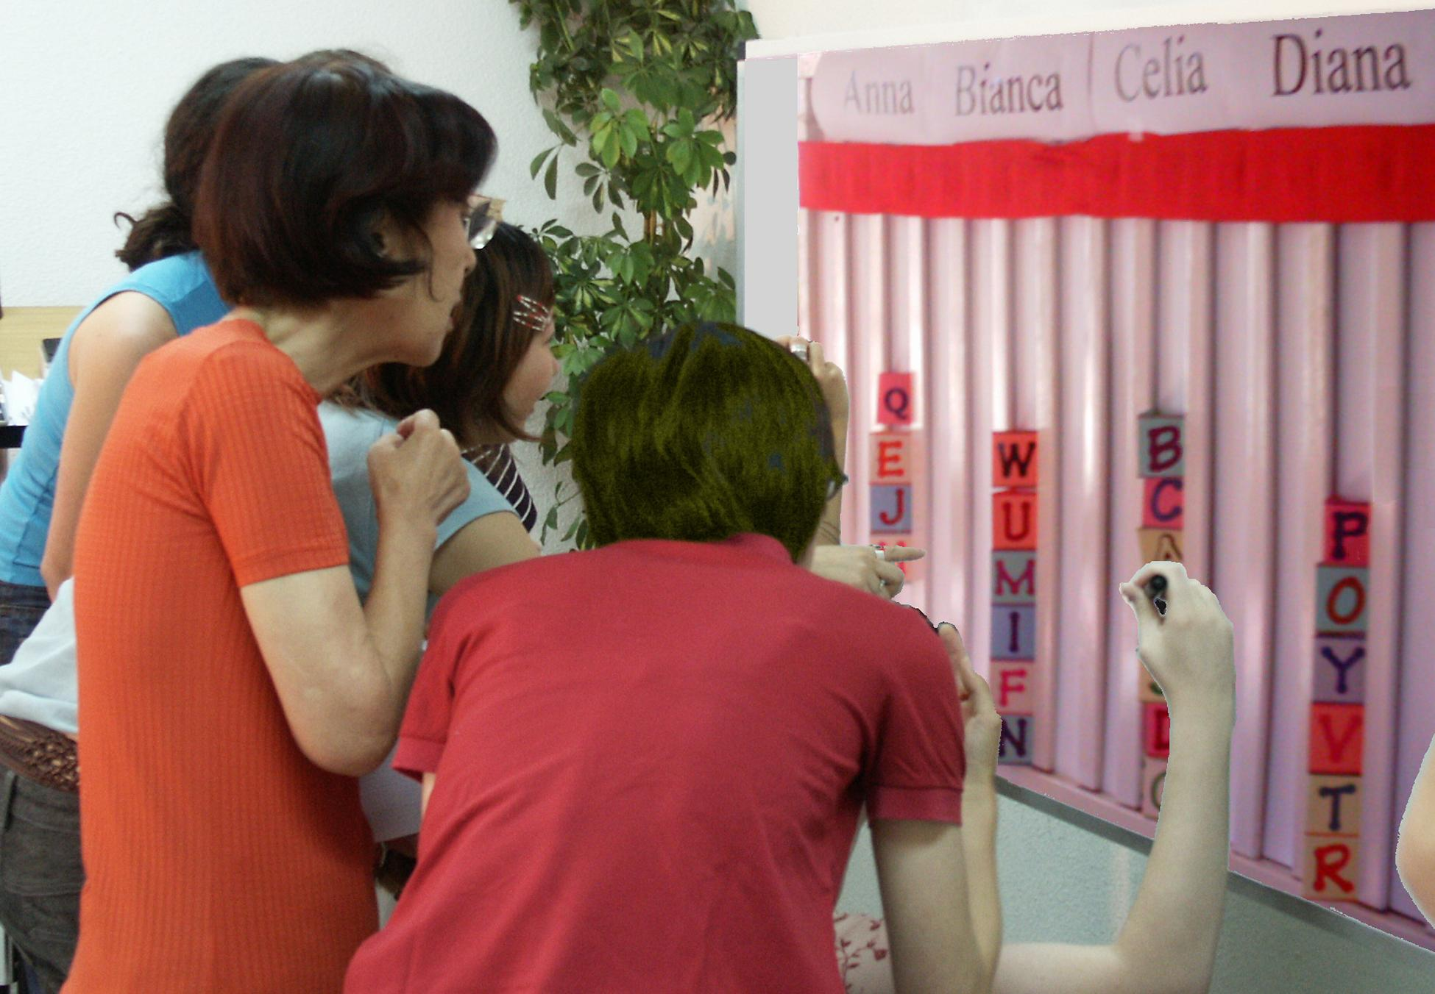

A Tally Board has:
 A card for each voter,
A column for each option,
A finish line for the favorites.

Instant Runoff Voting Elects 1 Winner
 The finish line marks the height of half the cards + 1.
That is how many votes a candidate needs to win.
Eliminate the weakest candidate if no one wins.
Draw names from a hat to break ties.
Move your card if your candidate loses.
This is your “movable vote”.
Repeat until one candidate reaches the finish line!
By organizing voters, Instant Runoffs avoid:
Spoiler candidates and the lesser-of-two-evils choice;
Costly runoffs and winners-without-mandates.
This chart shows four columns on a tally board.
The rule eliminated Anna so voter JJ moved his card.
Then Bianca lost so BB and GG moved their cards.
IRV elects leaders in London, Sidney, San Francisco…
It elects students at Duke, Rice, Reed, MIT, UCLA…
Anna  Eliminated 1st |  | Bianca  Eliminated 2^{d}
 |  | B B
J J |  | G G
1. How can your group use this voting rule?
2. A card that moves is no bigger than any other: T, F
3. Your 2nd choice vote can’t hurt your 1st choice: T, F
4. Only one candidate can reach 50% + one vote: T, F

Single Transferable Vote Elects 3 Reps
 The finish line marks the height of 1/4 of the cards + 1.
Do not give a card to a candidate who has finished.
Eliminate the weakest candidates one at a time.
Move your cards until three candidates win!
STV is used in many Australian and Irish elections,
at Princeton, Harvard, Berkeley, Oxford and Cambridge,
in some labor unions and in the Church of England.
It increases choices for voters and turnout of voters.
It elects more women and political-minority candidates.
It gives each group their fair share of council seats.
It increases the effective votes, those which elect reps.
5. What total percent must three STV reps win?
6. Only three candidates can win 25% + one vote: T, F
Ask questions one thru three with each voting rule.
Celia  IRV Winner |  | Diana  Runner up

Finish Line__Finish Line__Finish
B B
J J |  | G G
T T |  | Z Z
K K |  | D D
C C |  | V V

Movable Money Vote Buy Public Goods
 Let's say we each put in $1 to buy some items.
You get two 25¢ voting cards and a 50¢ card.
We say an item needs modest support from 8 of us
to prove it is a public good worth public money.
So the finish line marks the height of 8 cards.
You may put only one of your cards in a column.
So you can't dump all your cards on a private item.
Tip: Give your double card to your favorite treat.
This way 4 eager voters can fund a low-cost treat.
A costly item must fill several columns. A column
here holds $2, so a $4 item must fill 2 columns.
When an item wins, the banker hides its cards. We drop any item that costs more than all the cards left.
Then one at a time, we drop the least popular item,
with the lowest level of cards in its columns.
Move your card from a loser to your next choice.
You may try to save a threatened favorite by briefly withholding your cards from lower-choice items.
We stop when all remaining items are paid up.
Only a few items can win, but all voters win treats!
7. Should we let each voter or rep fund private items?

Budget Refill Votes Adjust Departments
 A big department has several columns to fill.
The columns each need $100... for the department
to reach last year’s budget; that's its refill line.
A supporter’s cards help refill its budget columns.
Voters can push it above its refill line.
But its gain will be another program's loss.
Let's say a council of 20 decides each program needs modest support from 10 members to restore its funding.
So a column needs 10 cards from 10 voters to reach its
refill line, or as few as 5 double cards from 5 eager voters.
This group wants to budget 4 low-cost activities with 1 column each, plus 3 costly programs with 2 columns each. Those 10 columns X 10 cards to refill each = 100 cards.
The 100 cards / 20 voters = 5 cards for each voter; 1 double and 3 singles. You may put only 1 in a column.
Set target budgets and rank your priorities.
As a budget nears your target, its priority goes down.
So move your cards to your next under-funded priority.
We stop voting when a hidden timer sounds.
This deters faking votes until a last-minute switch.
A supermajority may reopen the voting.

Pairwise Centers a Policy
 Flag C stands at our center, by the median voter.
Three flags surround C, about 5' from it.
Pairwise asks: "Are you closer to flag A than B?
If so, please raise your hand." Then A against C, etc.
We put each total in the Pairwise table below.
The winner must top every rival, one-against-one.
against | A | B | C | D
for A | — | 2 | 2 | 3
for B | 5 | — | 2 | 3
for C | 5 | 5 | — | 4
for D | 4 | 4 | 3 | —
A pole stands at our center, by the median voter.
It holds a short Red ribbon and a long Blue one.
If the Red ribbon gets to you, the Red policy gets
your vote with its narrow appeal.
But if the Red cannot touch you, the wide appeal
of the Blue policy gets your vote. Which one wins?
If the flags are places for a heater in an icy cold room:
8. Do we put it at our middle or in the biggest group?
9. Do we turn on its fan to spread the heat wide?

Full-Choice Ballots
Only a small group can crowd around a tally board.
Big groups use paper ballots, often tallied by computer.
Old-fashioned ballots oversimplify most issues.
They let you mark only one option “yes”, leaving all others “no”. This creates false dichotomies, limited choices that polarize voters and increase conflict.
Full-choice ballots reduce those negative results.
They let you rank a 1st choice, 2nd choice, 3rd etc.
Ranks reveal the labels, “us versus them” or left
versus right, hide moderate points of view.

These rules strengthen votes and thus mandates. They organize voters and lift the number supporting
a Chairperson from a plurality to a majority,
a Council from a plurality to over three quarters,
a Budget from a few power blocs to all members
a Policy from a one-sided to an over-all majority.
Learn more at AccurateDemocracy.com.
Then build support in your school, club or town with FairVote, The Center for Voting and Democracy.
Answers: IRV T, T, T. STV 3/4, T. MMV no. PW: mid, yes.
© 2008, Robert Loring, votingsite@aol.com

