
Accurate
↑
Democracy

4 Great Tools in Color

Help Groups from Classrooms to Countries
“This is the site for learning about democracy.”
—Zoe Weil, author of Most Good, Least Harm,
president of the Institute for Humane Education.

“...a huge contribution to the democracy cause.”
—John M. Richardson Jr., former Chairman of the National Endowment for Democracy.

“Congratulations on a brilliant piece of work.”
—Robert W. Fuller former President of Oberlin College, author of Somebodies and Nobodies, and All Rise.
The primer, games and pictures let you
Read, Touch and See How
The best types of voting are fast, easy and fair. They help groups from classrooms to countries.
They are inclusive yet centered and decisive.
One fast tool compares the votes for several
$ $
$
$ $

versions of a policy. Two tools give
1
fair shares of seats or $pending.
to Use and Enjoy
Share this colorful eBook with friends.
Grow support in your school, club or town.
Enjoy better politics, relations and policies.
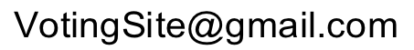
by Robert Loring

Contents
$ $
$
$ $
1
The four best voting tools are fast, easy and fair.
Parts A, B, and C reveal how tools steer power.
A. Voting Primer tells the stories of the four tools
Tragedies, Eras and Progress of Democracy 4

1. Elect a popular Leader by Ranked Choice Voting 10

2. Elect Representatives by Fair Representation 16

3. Set optional Budgets by Fair Share Voting New 22

4. Enact a balanced Policy by a Condorcet Tally " 28

Rigged votes, Gerrymanders and Gridlock 32

✵ Social Effects of group-decision tools 34

Consensus on one Policy or many Budgets 36

How you can try a group-decision tool 38

B. Workshop Games let us be inside the four tallies

1. Leader, 2. Reps, 3. Budgets, 4. Policy New! 39

C. SimElection™ games make tally patterns visible
2. Reps, 3. Budgets, Council, 4. Policy New 48

↑ Back Matter, Voting reforms aid more reforms ↑ 57

Countries with Plurality, Runoffs, or Fair Rep 60

About Us, ©, Endnotes, Index & Glossary 62
A. Voting Primer

Two of Many Tragedies
Old ways of adding up votes fail to represent large groups in many places. In the USA, North Carolina had enough Black voters to fill up two election districts. But they were a minority spread out over eight districts. So for over 100 years, they won no voice in Congress. As voters, they were silenced—with tragic results.
The Northwest tore itself apart by changing forestry laws again and again. In a year with weak forestry laws,
hasty logging wastes resources. But sudden limits on logging bankrupt some workers and small businesses. If this policy pendulum swings far, it cuts down forests and species, then families and towns, again and again.


What can big swings in other policies do?
4

What’s Wrong
We all know how to take a vote when there are only two candidates: We each vote for one or the other. For such a contest, the yes or no votes say enough.
But as soon as three candidates run for one office,
the contest becomes more complicated. Then that
old yea or nay type of voting is no longer suitable.
It’s even worse at giving fair shares of council seats, setting many budgets, or finding a balanced policy.
Our defective voting rules come from the failure to realize this:
There are different uses for voting, and some need different types of voting.

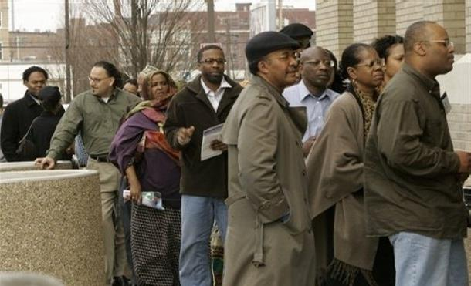
Will their votes be effective?
5
Eras, Tally Rules and Councils

In the 19th Century
Winner-Take-All Districts  Off-Center Councils

$ $ $ Policies $ $ $
Typical Council Elected By Plurality Tallies
.
Some former colonies still count votes by England’s old plurality voting rule. It elects only one rep from each district — and winning does not require a majority. It merely elects the one who gets the most yes votes.*
A district with only one rep tends to develop only two big parties. Only their candidates have good chances. It gets worse: a district’s bias often makes it a “safe seat” a captive audience for one party. So voters in a plurality district are given very little choice or no real choice.
If the voters in a few districts are given real choices, all power might flip from one faction of reps to another. Hopes and fears of budget or policy flips polarize politics. Each battle is brutal because it is winner take all.
* Each voting rule or system defines its ballot and its tally. 6

In the 20th Century
Fair-Rep Elections ⇨ One-Sided Majorities


$ $ $ Policies $ $ $
Typical Council Elected By Fair Representation

Fair Representation was developed around 1900 to end some major problems caused by plurality rule. Most democracies now use “Fair Rep.” It elects several reps from each election district. It gives a group that earns say, 20% of the votes, 20% of the council seats. So Fair Rep delivers fair shares of representation.
It’s often called Proportional Representation or PR.
It leads to broad representation of issues and views. But usually there is no central party (C above) and the two biggest parties normally refuse to work together. So the side with the most seats forms a ruling majority. Then it enacts policies skewed toward its side.
7

In the 21st Century
Ensemble Councils  Balanced Majorities

$ $ $ Policies $ $ $
Council Elected by Central and Fair-Rep Rules

Ensemble rules will elect most representatives by
Fair Rep, plus a few reps ( C above) by a central rule.
So the points of view within the council will have a spread, plus a pivotal midpoint, that match voters more accurately. O + ● =  That’s the target*
Later pages will show how a we can elect a rep with wide support and views near the center of the voters. So winners will be near the center of a Fair Rep council.
There they can be the council’s powerful swing voters, with strong incentives to build moderate majorities.
Many voters in this wide base of support won’t want narrow centrist policies. They’ll likely prefer policies to combine the best suggestions from all groups.
* It’s colors suggest archery or political bunting. 8
 | Progress of  Democracy | 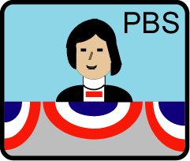

A centrist policy implements a narrow set of ideas. It blocks rival ideas: opinions, needs, goals, and plans. A one-sided policy also blocks rival ideas.
A compromise policy tries to negotiate all the ideas. But contrary ideas forced together often work poorly.
A balanced policy blends compatible ideas from all sides. This process needs advocates for diverse ideas. And more than that, it needs independent moderators. These swing-voting reps can please their wide base of support by building moderate majorities in the council.

A broad, balanced majority works to enact broad, balanced policies. These tend to give the greatest chance for happiness to the greatest number of people.
Excellent policies are a goal of accurate democracy. Measure their success by the typical voter’s education and income, freedom and safety, health and leisure.
Older rules often skew results and hurt a democracy. An ensemble is inclusive, yet centered and decisive —to help make its actions popular, yet stable and quick. The best tools to set budgets or pick a policy will also show these qualities in our stories, graphics and games.
9

1. Electing a Leader

Nine Voters
Let’s think about this election: Nine voters want to elect a leader. The figures in this picture mark the positions chosen by those voters. They stand along a political spectrum from left to right. It is as though we asked them, “If you want high-quality public services and taxes like France or Germany, please stand over  here. Stand here  if you want to be like Canada. To be like the USA stand over here . For Mexico’s low taxes and government services stand over there .”
Throughout this booklet, we’re going to show political positions in this compelling graphical way.
.
.
.
.
Nine voters spread out along an issue.
High taxes buying Low taxes buying
great gov. services poor gov. services
These colors aid readers less able to see colors. 10

Plurality Election
Here we see three rivals step up, asking for votes.
Each voter prefers the one with the closest position.
A voter on the left votes yes for the candidate on the left.
Ms. K is the candidate nearest four voters.
L is nearest two and M is nearest three.
Candidates L and M split the voters on the right.
Does anyone get a majority (over half), Yes or No?
Who gets the plurality (the largest number), K, L or M?
Who gets the second-largest number of votes?
Answers to questions are at the bottom of each page.
A mere plurality gives the winner a weak mandate.
This is the authority effective votes loan to a winner,
by consent not coercion. Strong mandates support
and speed action to reach popular goals.

By plurality rule, the one with the most votes wins.
K is nearest four voters. M is nearest three.
L is nearest two.
Answers: No. K. M. 11

Runoff Election
From the plurality tally, the top two may advance to
a runoff. It eliminates the other candidates all at once.
The two voters who had voted for L now vote for M.
Do they each have more power than some other voter?
Wasted votes fail to turn a loser into a winner.
Effective votes succeed; a voting tally with more
of them is more accurate, fair and responsive.
Does the plurality election waste more votes? Does that discourage members from voting?
Does the runoff make a stronger mandate?
Runoffs practically ask, “Which side is stronger?” Later, these voters will use another voting rule to ask, “Where is our center?” And a bigger group will use
a rule to ask, “Which trio best represents all of us?”
In a runoff, the top two compete one against one.
Four wasted votes. Candidate M wins a runoff.
Answers: No, each voter has one vote in each tally.
Yes, five votes. Yes. Yes, a majority mandate. 12

Politics in Two Issue Dimensions
When more issues (or identities) concern the voters,
a voting-tally rule keeps its character.
Here we see voters choosing positions spread over two issue dimensions: left to right plus up and down. A person’s position on one dimension is little help for predicting their position on the other one.
A voter may rank candidates on any issue(s).
He prefers the candidate he feels is closest.
“Please step up for more protective regulations. Please step down if you want fewer protections.
Take more steps for more change.”
The chapter on simulation games and research shows more tallies with two and even three issue dimensions.

Seventeen voters take positions on two issues:
more or less regulation □ and taxes for services 
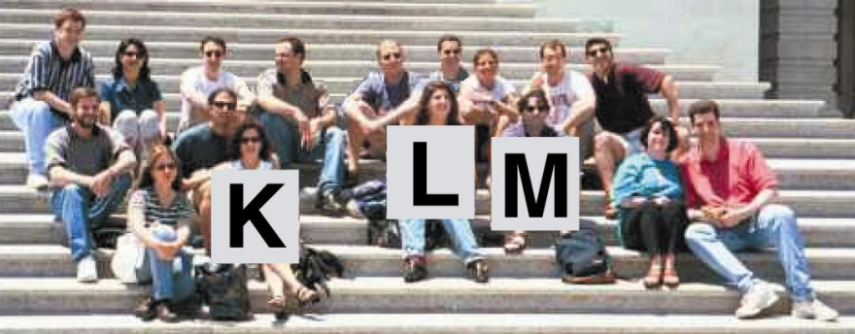
K wins a plurality. M wins a runoff.
For clarity, a candidate is “she” and a voter is “he.” 13

The goal of Ranked Choice Voting is this

A majority winner,
from a single election.
Voting is easy. Rank your favorite as first choice, and backup choices: second, third, etc. as you like* Your civic duty to vote is done.
Now your vote counts for your top-ranked candidate.
If no candidate gets a majority, the one with the fewest
votes loses. So we eliminate that one from the tally.
Your vote stays with your favorite if she advances.
If she has lost, then your vote counts for your backup.
This repeats until one candidate gets a majority.

Why Support Ranked Choice Voting, RCV
Backups give you more power and freedom to express opinions with less risk of wasting a vote.
No hurting your first choice by ranking a backup, that does not count unless your first choice has lost.
No worry about vote splitting in a faction as votes for its loser(s) can count for each supporter’s backup.
More civility and consensus arise as candidates 
ask fans of rivals, "Rank me as your second choice."
A majority winner from one election, so no reps with weak mandates and no costly runoff elections.
High voter turnout also creates strong mandates The turnout for an election runoff often goes down.
*Pages 33 and 45 show ballots. 14

Ranked Choice Voting Patterns
Running for president of South Korea, the former aide to a military dictator faced two reformers. The two got a majority of the votes but split their supporters. So the aide won a plurality. (37%, 28%, 27%, 8%) Years later, he was convicted of treason in the tragic, government killing of pro-democracy demonstrators.
A voter’s backup is often like his favorite, but more popular. So by dropping one reformer, RCV might well have elected the stronger one with a majority.

1 2 3 4
From five factions to a majority mandate.
1) Violet loses; so backup choices get those votes.
2) Amarilla loses; so backup choices get those votes.
This chief executive starts in a big band of voters on the biggest side, then builds a majority. This helps her work with reps on the biggest side of a typical council.
→ For 11 years, Papua New Guinea used RCV, then
plurality rule for 27 years; ethnic violence increased.
They changed back to RCV and the violence decreased.
Irish and Australian voters have used it for decades. They call it the Alternative Vote or Preferential Vote. In the USA, some call it Instant Runoff Voting, IRV.
The endorsements page lists many groups using it.
It often helps women achieve parity in politics.
The workshop shows an RCV game on pages 39-42. 15

2. Electing Representatives

The principle of Fair Representation is:
Majority rule by representing the groups in proportion to their voters.
That is, 60% of the vote gets you 60% of the seats,
not all of them. And 20% of the vote gets you 20% of
the seats, not none of them. These are fair shares.
How does it work? There are three basic ingredients:
We elect more than one rep from an electoral district.
You vote for more than one; you vote for a list. You pick a group’s list, or you list your favorites.
The more votes a list gets, the more reps it elects.

Why Support Fair Representation, Fair Rep
Fair shares of reps go to the rival groups so Diverse candidates have real chances to win so Voters have real choices and effective votes so
Voter turnout is strong.
Women win two or three times more often¹ so Accurate majorities win—also due to more: choices, turnout, effective votes and equal votes per rep so Policies match public opinion better.
Many people call this Proportional Representation, PR.
16

Fair Shares and Moderates
Chicago elects no Republicans to the State Congress,
even though they win up to a third of the city’s votes. But for over a century it elected reps from both parties. The state used a fair rule to elect 3 reps in each district. Most gave the majority party 2 reps and the minority 1. So no district was unwinnable and neglected by 1 party, a captive audience for the other party.
Those Chicago Republicans were usually moderates. So were Democratic reps from Republican strongholds. Even the biggest party in a district tended to elect more independent-minded reps. They could work together for moderate policies.

✓ Shares of votes equal fair shares of seats.

New Zealand switched in 1996 from Single-Member Districts to a layer of SMDs within Fair Representation. They call this Mixed-Member Proportional or MMP. A small, one-seat district focuses more on local issues. Fair Rep frees us to elect reps with widespread appeals.
The seats won by women rose from 21% to 29%. The native Maori reps increased from 7% to 16%, which is almost proportional to the Maori population. Voters also elected 3 Polynesian reps and 1 Asian rep.
17

Why It Elects More Women
New Zealand and Germany elect half of their MPs
in Single-Member Districts and half from Fair Rep lists.
This is the best way to elect a parliament, some say. The SMDs elect few women; but in the same election, the party lists elect two or three times more women.¹
The safest nominee for a party in a Single-Member District, is from the dominant gender, race, religion, etc. So SMDs often lead to poor representation of others.
Fair Rep leads a party to nominate a balanced team of candidates to attract voters. This promotes women. A team can have class, ethnic, and cultural diversity. And that gives us diverse reps to approach for help.
MORE: Competition, Real choices, Voter turnout, Effective votes, Strong mandates, Diverse reps, Women reps, Popular policies
Some leading women spoke of starting a new party in Sweden, which uses Fair Rep. Under plurality rule, a big new party splits their own side, so it likely loses. But Fair Rep gives every big party its share of seats.
This credible threat made one old party decide job experience was not as important as gender balance. So it dropped some experienced men to raise women higher on their party’s list. And they won. Now they are incumbents with experience, power and allies.
18

Voting Rules and Policy Results
Local SMDs can elect reps with unequal vote totals. So a majority of reps might not represent most voters. Fair Rep uses more equal votes for each rep. (p. 20-21) So each majority of reps does stand for most voters, producing policies closer to public opinion.²
Less: Wasted votes,
Gerrymandered districts,
Monopoly politics,
Dubious democracy
Many voters see a woman in a multi-winner race less as fighting her rivals, more as supporting her issues.
Councils with fewer women tend to do less for health care, childcare, education and other social needs. Then the poorest schools and clinics are blighted; so are the citizens and workers hurt by poor health or education.
If such urgent needs overwhelm us, we neglect
the essential need to fix their structural sources.
The plurality rule is a key defective part to replace.
It wastes votes and underrepresents most voters.
It gives the reps less incentive to help most voters.
A more accurate democracy leads toward a better quality of life, as measured by the scores on page 60. We would all like better quality-of-life results for our country, and for our towns, schools, clubs and co-ops. So help friends talk about and try these voting rules.
19

Three Single-Winner Elections
A class of 27 wants to elect a 3 member committee. Someone says, “Elect a rep from each seminar section. To win here, you need to get the ballots of just 5 voters.”
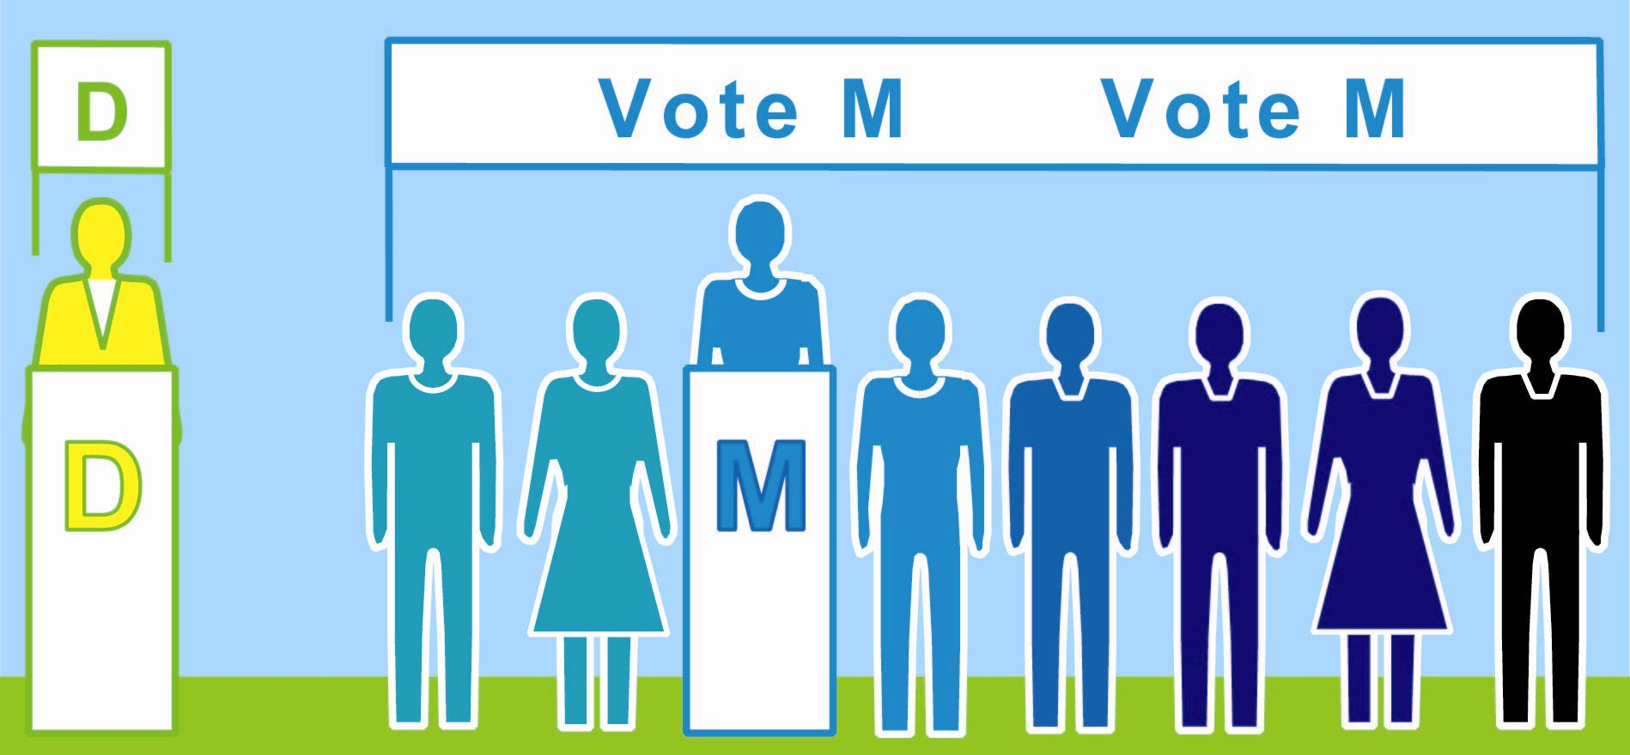
Sectionİ One
1 vote
wasted on a loser
8 M
votes; 3 are wasted in a surplus
l l l l l l l l l

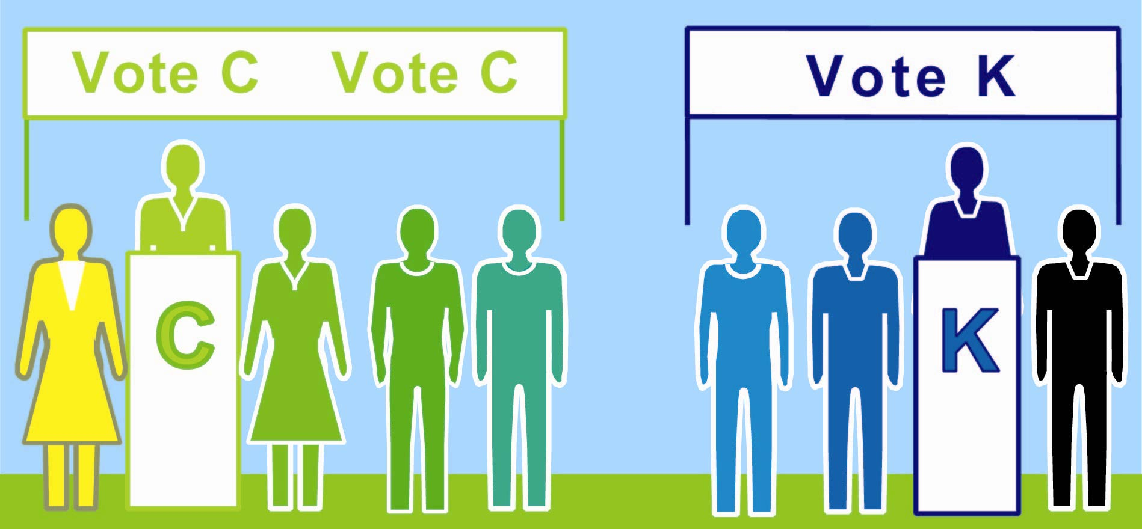
=

=
=
=

=
=

=
4 K
votes wasted on a loser
Sectionİ Two|
5 C
votes elect a rep

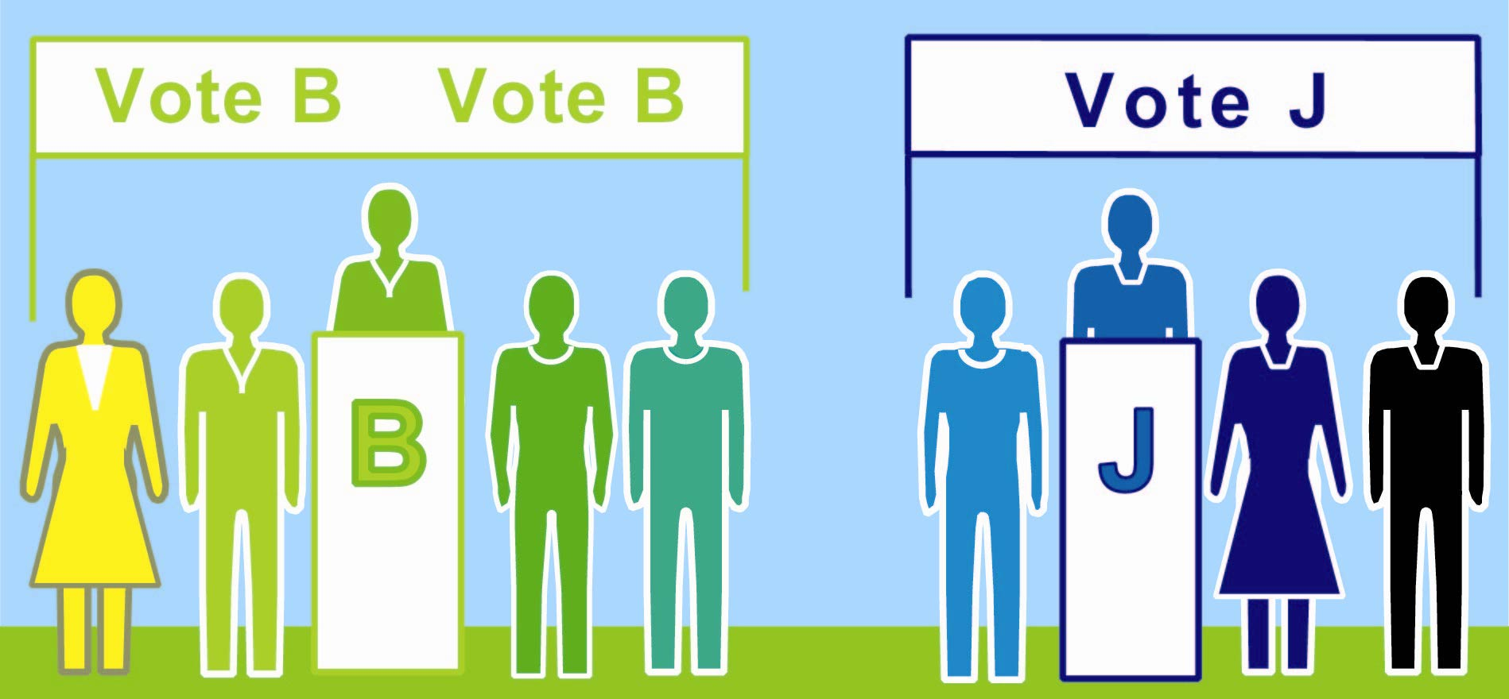
Sectionİ Three
5 B votes elect a rep
4 J
votes wasted
on a
loser
... ... ... ... ... ... ...
◆ An 11 voter minority gets 2 reps; that’s majority power. If spread out, 3 or 4 in each section, they’d get no rep.
It can waste many votes so it’s erratic and easy to rig.
How many votes were wasted? 12 20

One Fair Representation Election
A better idea, “Keep the class whole. Change the votes needed from 1/2 of a section to 1/4 of the class plus 1. To win here, you need the ballots of 7 voters.
A voter may rank a first choice and a backup choice.
If his first choice loses, his vote counts for his backup.”
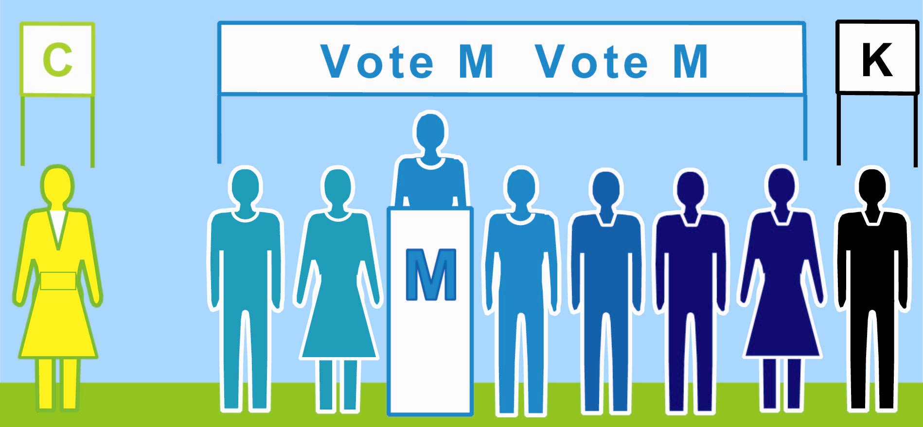
M wins. Any surplus helps each voter’s backup
All 3
sections together
l l l l l l l l l
 7 voters rank M > K > J.
=

=
=
=

=
=

=
4 votes
help
elect K
5 votes
help
elect C
 6 rank C > B.
J loses;
these backup choices help elect K
B loses;
these backup choices
help elect C
C
K
... ... ... ... ... ... ...
Final 11 C (4 surplus) 7 M 9 K (2 surplus)
◆ Now the minority gets 1 rep and the majority gets 2.
Their mandate is fair, accurate, popular and strong. 21
3. Allocating Budgets

Fair Shares to Buy Shared Goods
Electing reps is the most obvious use of voting rules. Rules to pick projects or a policy are also important. These group decisions occur more often than elections. They even occur in many groups with no elections.
The members of clubs, co-ops, colleges, grant givers and more can enjoy the merits of Fair Share Voting.
Fair Representation distributes council seats fairly. Likewise, votes can distribute some funding fairly.
Democratic rights progress. Each step is more fair, thus accurate, responsive, widely-supported and strong.
✓ Voting by rich men, poor men, Black men, women
Fair Representation of all big political groups
Fair Share Voting by big groups of voters or reps

$ $ $ $ Policy $ $ $ $ $
All big groups have the right to spend some funds.
22

Patterns of Unfair Funding
Participatory Budgeting, PB, lets neighbors research,
discuss and vote how to spend part of a city’s budget. In South America it spread from one city in 1989 to hundreds today. Progress often advances this way.
The World Bank reports PB may reduce corruption and it tends to raise a community’s health and education.
In 2010, a Chicago alderman gave $1,300,000 to PB. But a plurality rule made the votes and voters unequal. For example, in 2011 each vote to help a park won $501. That was its cost divided by its voters. But if cast for the bike racks, each vote won a mere $31. That’s too unfair. Even worse, most of the votes were wasted on losers.

✓✓✓✓
A costly winner makes many lose.
•
• •
A bad election rule gets worse when it picks projects. It is not cost aware; so it often funds a very costly item and cuts a bunch that get many more votes per dollar. To win this bad tally, load various proposals into one. Keep raising its cost if that attracts more votes.
One year, a scholarship fund got many surplus votes. These were wasted votes because they had no effect. So the next year, some supporters chose not to waste a vote on this “sure winner.” It lost! They saw the need for a voting rule that would not waste surplus votes.
A voter’s PB share is sometimes over $1,000. 23

The principle of Fair Share Voting is:
Spending power for groups,
in proportion to their voters.
So 60% of the voters can spend 60% of the fund, not all of it. Your ballot’s share from the fund lets you vote to pay your shares of the costs for your favorite items.
Voting is easy: simply rank your choices, like in RCV.
Your ballot pays one share for each of its present top ranks—as many as it can afford. A tally of all ballots drops the item with the fewest shares. Those two steps repeat until each remaining item gets full funding.³
Paying one share proves you feel the item is worth its cost and you can afford it in your high priorities.

Some Merits of Fair Share Voting, FSV
A winner is a popular priority worth its cost
To qualify for funding from our group’s source, an
item needs our “base number” of voters or more.
FSV is fair to an item of any cost and to its voters:
A ballot pays a costly share to vote for a costly item.
cost / base = 1 share e.g. $100 / 25 ballots = $4 If more ballots divide a cost, each of them pays less.
So, a ballot’s money can help more low-cost items.
This motivates each voter to give his top ranks to
the items that give him the most joy per dollar.
See also RCV points 1 and 3 on page 14. 24

Fair Shares and Majorities
If a majority controls all the money, the last item they choose adds little to their happiness; it’s a low priority. FSV lets that money buy a high priority of another big interest group, adding more to their happiness.
In political terms: The total spending has a wider base of support: It appeals to more voters because more see their high priorities get funding.
In economic terms: The social utility of the money and winners tends to rise if we each allocate a share. Fair, cost-aware voting gives more voters more of what they want for the same cost = more satisfied voters. Shares also spread good opportunities and incentives.
.
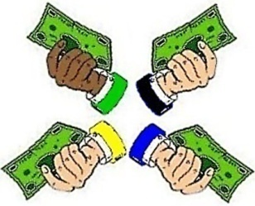
✓ ✓
Items
Goods
Services
Projects
Programs
Budgets

✓ ✓
Fair shares
spread the joy and opportunities.
Plurality rules let surplus votes waste a big group’s power, as seen on page 20, or let rival items split it. The biggest groups often have the biggest risks.
FSV protects a majority’s right to spend a majority of the fund. It does this by eliminating split votes, as did RCV, and surplus votes, as we’ll soon see.
25

Budget Levels
A co-op that helped develop Fair Share Voting lets each voter rank budget levels for some items.
A budget level needs to get the base number of votes.
It gets one if a ballot offers to share the cost up to that level or a higher level. cost / base = 1 share = 1 vote
The item with the weakest top level loses that level. Any money your ballot had offered to it moves down your ballot to your highest ranks that lack your support. This repeats until the top level of each item is fully funded by its supporters. Thus fair shares and backup ranks select a set of winners with more supporters.
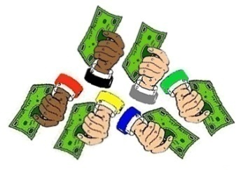
✓

✓ ✓
Many voters must prove, “This cost
is a high priority within my budget.”
A group with 100 members set our base number at 25 votes. My first choice got just enough votes, so my ballot paid 4% of the cost. 100% / 25 votes = 4%
My second choice lost; did it waste any of my power?
My third choice got 50 votes, so my ballot paid only 2% of the cost. Was there any surplus? Did I waste much of my power by voting for this sure winner?
None. None. Not much. 26

More Merits of Fair Share Voting
After discussion, a quick poll can pick many items. It reduces agenda effects such as leaving no money for the last items or going into debt for them.
It lets subgroups fund items; so it’s like federalism
but without new layers of laws, taxes and bureaucracy. And it funds a big group even if they are scattered.
Each big group controls only its share of the fund. This reduces their means and motives for fighting. It makes (hidden) empires less profitable.
Fairness builds trust in spending by subgroups and raises support for more. This can reduce spending at the extremes of individual and central control.
N€w N¥w
New Tool
N₤w N$w

Merits of FSV for an Elected Council
FSV gives some power to reps in the opposition, so Electing them is more effective, less of a wasted vote
They can relieve starvation budgets that hurt projects. This makes project management more efficient.
A voter can see grants from his rep to each project,
tax cut, or debt reduction; then hold her accountable.
In games, we may vote for treats and eat the winners!
27

4. Enacting a Policy

Condorcet Test Number Two
The Runoff on page 12 was a one-against-one contest between the policy positions of M and K. Five voters ranked M’s position over K’s. 5 > 4
Here is a second test with the same voters:
K’s position loses this one-against-one test.
L's position wins by five votes to four. 5 > 4
Each person votes once with a ranked choice ballot. Pages 33 and 46 show two common, simple ballots.
A workshop page will show a pairwise tally table.
And a simulation map will show Condorcet voters
with two issue dimensions.
People often struggle to find
a group’s center of opinion
K is nearest four voters. L is nearest five voters.
28

Condorcet Test Number Three
Candidate L wins her last test by six to three. 6 > 3
She has won majorities against each of her rivals. So she is the “Condorcet winner.” L > M. L > K.
“…such a mandate is no doubt a vital ingredient
in the subsequent career of the winner.”
Who is the Condorcet winner on page 13, K, L or M?
Thus a Condorcet Tally picks a central winner:
It can elect a moderator to a council, see page 8,
or moderates from districts for MMP, see page 17.
or senators for an upper house.
But is it likely to elect diverse reps, yes or no?
It can sellect the base number for FSV, see page 26. But is it likely to spread spending fairly, yes or no?
Do CEOs mostly moderate, or advocate, e.g. a mayor?
.
1

L has six votes. M has three.
Answers: L. No. No. Discuss this. 29

The goal in a Condorcet Tally is this:

Majority victories,
over every single rival.
The winner must top every rival, one-against-one.
A good analogy is a “round-robin tournament.” A player has one contest with each and every rival. If she wins all her tests, she wins the tournament.
Each voting test sorts all the ballots into two piles. If you rank option K above L, your ballot goes to K.
The option that gets the most ballots wins this test. If one wins all its tests, it wins the Condorcet Tally.
(But in a rare, “voting cycle,” majorities rank K > L,
L > M, and M > K. RCV can break the tie. )
K L

M
.

Why Use a Condorcet Tally, CT
Choice ballots: rank the related options on 1 ballot. Simplify the old rules of order and speed up voting. Reduce agenda effects, from simple errors and gridlock, to “free-rider” and “wrecking” amendments.
No split-vote worries as duplicates don’t help or hurt each other. An ad hoc majority can rank all of their favorites over the other options. Ballots from all voters help decide which of the majority’s favorites wins.
A balanced policy tends to be stable, thus decisive. Yet, a balanced process can calm some fears about reviewing and changing a good policy to improve it. Both save time and build respect for democracy. 30

Achieve Policies with Wider Appeal
A plurality or runoff winner gets no votes from the losing side and doesn’t need to please those voters.
But each CT option needs support from all sides, because every voter can rank it against its close rivals. Thus every CT voter is “obtainable” and valuable.
So the winner is well balanced and widely popular.^{2, 3} Voters on the center and right give it a majority over any left-wing policy. At the same time, voters on the
left and center like it more than any right-wing policy. All sides like it more than a narrowly-centrist policy.

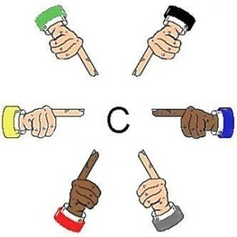
“Our center
is near me.”
“I think it’s
right here.”
“I am the
center!”
Everyone helps locate our center.

A Chair with Balanced Support
CT can elect a chairperson or a few reps to be the swing voters in an Ensemble Council, as pictured on pages 8 and 54. To win, a candidate needs to earn wide support. This gives her strong incentives to help the council balance its process and policies.
RCV has slightly different effects, incentives and uses.
Games will let us inside each tally to feel how it works.
31

Resist Rigged Votes
In the plurality election on page 11 candidate M lost. Now let’s say her party gerrymanders the borders of her election district. It adds in voters, pictured in purple, who tend to like the party and cuts out some who don’t. In this safe-seat district, bluish voters can elect M or an even less central person who may polarize politics.
But this gerrymander didn’t change the CT winner, L. So policies stay stable and take big swings less often.
3 rank K>L>M. 2 rank L>M>K. 4 rank M>L>K.
To steal a one-seat district that uses CT or RCV, $ponsors must mislead a majority, not just a plurality.
And help to "spoilers" in a rival group fails to split it.
Gerrymanders always increase wasted votes. Proportional RCV avoids both, as shown on page 21.
Foul manipulations of plurality rules are not rare. And point voting invites extreme high and low votes, as
voters worry, “Do my lower choices hurt my top choice?” But a chance to rig real RCV or Condorcet/RCV is rare, risky and hard.² There’s less danger of rigged votes. 32

A Less Rigged Agenda Now!
Some meetings concoct a policy by a series of yes-no choices, with or without rules of order, agendas or votes. An early proposal might have to beat each later one. An early decision might preclude some later proposals. So “stacking the agenda” can help or hurt proposals.
Other meetings discuss the rival options all at once. But often, many members express no backup choices. So similar options split supporters and hurt each other. Then a minority pushing one option can appear to be the strongest group. Even sadder, a member with a well-balanced option but few eager supporters might drop it.
Too often, a committee chooses all the parts in a bill. Other members can say only yes or no to that bundle. It might include free-rider or wrecking amendments.
Rigged votes often build bad policy and animosity. To reduce the risks, let the voters rank the options.

RCV Ballot On Issue A
Rank Option
3 Continue Discussion
2 Original Bill, the main motion
1 Bill with Amendment 1 (a free rider?)
8 Bill with Amend. 2 (a wrecking amend.?)
7 Bill with Amendments 1 and 2
4 Postpone for 7 days
5 Refer the Bill to a Committee
6 No Change (a vote for gridlock exposed?)
The “Incidental Motions” do not wait for the ballot,
e.g. a personal complaint or request. 33

Summary and Index of Benefits

Ranked Choice Voting has proven to pages
1,2,3,4. Make voting easy, more often effective. 14, 57
Give you power to rank a backup choice; so 33, 45
Reduce your risk of wasting your vote; so 12, 16
Vote worry free for your true first choice. 14
Boost mandates as more voters count. 11-21, 57

1,2.Reduce attack ads that scare, anger and polarize. 14
Weaken gerrymanders and spoilers. 14, 16, 32

2. Give fair shares of reps to the rival groups; so 16
Give diverse candidates real chances to win; so 18
Give voters real choices and effective votes; so 17
Make voter turnout stronger. 61

2. Elect women two or three times more often; so 18
Accurate majorities win–also due to more: choices, 17
turnout, effective votes and equal votes per rep; so 19
Make policies match public opinion better. 19, 60
Even then, old decision tools push policy pendulums. 4


✵ An RCV Toolbox can do more ♥
4. Elect a few central reps, the key votes pulling 31
reps of many factions to moderate policies. 8, 54

3. Use Fair Share Voting on projects, savings etc. 24
Reveal a rep’s spending; cut corruption. 27, 59

3,4. Reduce agenda effects and scams. 27, 30, 33, 36
Streamline group decision making. 27, 33, 36

Social Effects

These Are Tools Between People
A group’s decision rules pull its culture toward fair shares or toward winner takes all. They spread power wide and balanced, or narrow and lopsided. Other relations among members may follow their models.
Fair rules make cooperation safer, faster and easier. This favors people and groups who tend to cooperate. It can lead others to cooperate more often.
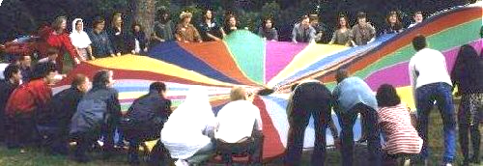
Politics are more principled and peaceful when all the rules help us find fair shares and central majorities. This might reduce political fears within our community; which helps us to be more receptive, creative and free.
So better tally rules can help us build better decisions, plus better relationships. Both can please most people. Fair rules won’t please some who get money or self-esteem from war-like politics. But countries with fair rules tend to rank higher in social trust and happiness. Voting is an exemplary tool between people.
35

Consensus and Voting
Group decision-making has two linked processes.
A discussion process may have a facilitator, agenda, some reports and proposals. Plus the members may suggest some questions and changes for each proposal. A decision process asks all members which proposals have enough support to be winners.
Voting only yes or no leads us to discuss and decide one formal “motion” at a time in a very strict sequence. It stifles the sharing of ideas and development of plans.
But both consensus and ranked choice ballots let us decide some closely-related options at the same time. Both reward blending compatible ideas, pages 9, 31
and polarize less than yes-or-no voting. " 14, 46, 56 So more members want to help carry out the decision soon and make it work; fewer try to slow it down.

Why Take a Vote
Discussing an issue well often resolves most parts, with mandates up to 100%. Yet we might want to decide some parts with the best voting tools. Why?
The best rules strengthen some reasons for voting:
Choice ballots can speed up meetings. pages 27, 33
Secret ballots reduce social pressure and coercion.
Well-designed ballots and tallies promote equality:
Even busy or unassertive people can cast full votes.
36

Complementing Consensus
Groups that seek consensus on basic agreements may vote on other issues: They may vote on a detail like a paint color or on a bunch of optional projects.
Fair Share Voting gives fair shares of power. Inclusive yet fast, it won’t let one person block action.
It is cooperative, not consensual or adversarial. It is less about blocking rivals, more about attracting allies. Its ballot guides a voter to limit and prioritize projects. Its tally weighs dozens of desires, of varied cost and priority, from dozens of intersecting groups. We may modify our FSV results through our usual process.
All majorities prefer the Condorcet winner. A proposal must top each rival by 50% plus one; and we may require it to win 60% or even 100% over the status quo on issues involving our basic agreements.
If so, 41%, or even one voter, may block a Condorcet winner by showing it breaks a basic agreement.

Carpentry Analogy
The nice consensus methods are like nice hand tools, and these nice voting methods are like nice power tools. The power tools speed cutting through piles of boards or issues, and cutting through a steel-hard one. The high-touch tools help us discover and develop insights into new options. So most of us want both kinds of tools.
This primer told the stories of the best voting tools.
The games will let us be inside the simple tallies. 37

How You Can Try a Voting Tool
It’s easy to test-drive a decision tool in a survey. Or a council can form a committee of the whole to discuss, vote, tally and report results to enact by their old rules.
Many groups adopt a book of parliamentary rules; then they amend it with “special rules of order” to make their decisions more popular, stable and quick.
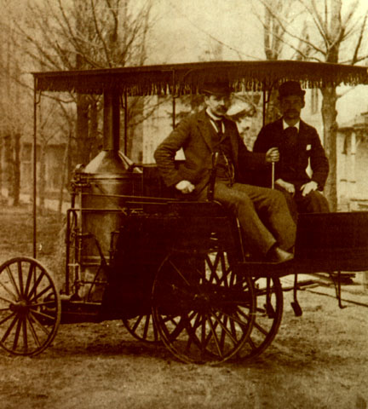

Steering Analogy
When choosing a voting rule, a new Mercedes costs little more than an old jalopy. That cost is a bargain when the votes steer important budgets or policies.
Does your car have an 1890 steering tiller or a new, power steering wheel? Does your town have an 1890 voting rule or a new, centrally balanced rule? e.g. p. 33
Some groups offer apps to tally your votes.
https://AccurateDemocracy.com/z_tools.htm
38

B. Workshop Games
Get your hands on 4 great voting rules.
See how fair-share tallies organize voters.
Vote fast for projects, reps or policies.
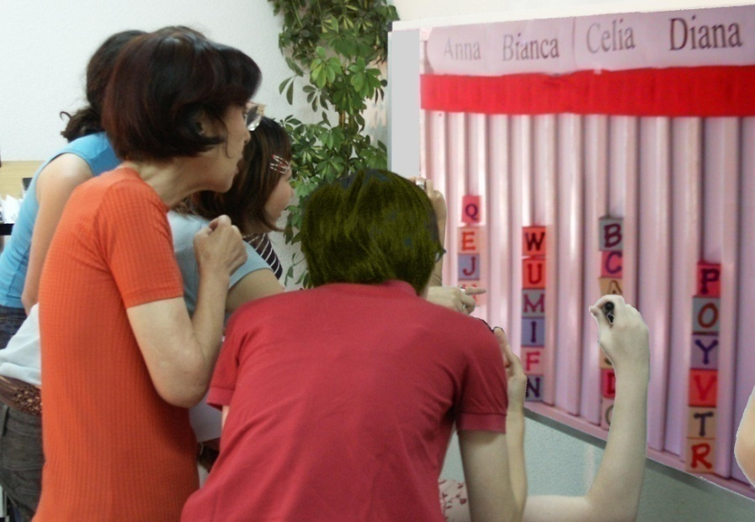

A tally board has
 A card for each voter,
A column for each option,
A finish line for the favorites.
39

1. Ranked Choice Voting to Elect One
Tabletop games make Ranked Choice Voting lively.
The finish line is the height of half the cards, plus one. That is how many votes a candidate needs to win.
If no one wins, we eliminate the weakest candidate. We draw names from a hat to break ties.
If your favorite loses, you can move your card. You can give it to your next backup choice.
We repeat this to eliminate all but one, the winner!
This chart shows four columns on a tally board.
The rule eliminated Anna, so voter JJ moved his card. Then Bianca lost; BB and GG moved to their backups.
They were free to choose different backups.
Anna  Eliminated 1st |  | Bianca  Dropped 2nd
 |  | B B
J J |  | G G

JJ ranks Anna 1, Celia 2. GG ranks Bianca 1, Diana 2.
Celia  RCV Winner |  | Diana  Runner up

Finish Line__Finish Line__Finish
B B
J J |  | G G
M M |  | D D
L L |  | Z Z
V V |  | C C
The winner had no surplus. The last loser held 4 votes.

Quiz on RCV to Elect One
1. How can your group use this voting rule?
2. A card you move counts just like others, True or False?
3. Ranking a backup can’t hurt your first choice, T or F?
4. Only 1 candidate can reach 50% plus a vote, T or F?
5. Name 4 cities or schools that use RCV. See page 62.
6. What benefits does it give them? See page 14.
Answers: 2) True, each card counts once in each round.
3) True, a backup doesn’t count unless your 1st has lost.
4) True, more reps would need over 100% of the votes.

Ranked Choice Voting includes RCV and PRCV.
The endosements page lists some of the users. ↓
Most of the groups tally their votes easily with apps.

2. Fair Rep by Proportional RCV
A tabletop game to elect three reps works like PRCV.
We set the finish line at ¼ of the cards plus one. Don’t put your card on a column that is full.
One at a time, we drop the weakest candidate.
If your candidate loses, you can move your card.
Repeat until three candidates reach the finish line!
Ask the RCV questions above again for PRCV adding:
4. Can only 3 candidates each win 25% plus a vote?
7. What total do a trio of reps win all together?
Answers for PRCV: 6) see page 16. 7) 75%.
PRCV with a cost-aware tally gives us FSV. 
PRCV is also known as Single Transferable Vote, STV. 42

3. Fair Shares Buy Shared Goods
For our tabletop tally of Fair Share Voting (FSV)
You get one share; here that's three 50¢ voting cards.
We decided an item needs modest support from six of us to prove it’s a shared good worth shared funding. So the finish line marks the height of six cards, and
You may put only one of your cards into a column.
A costly item must fill several columns. A column here holds $3, so a $6 item must fill two columns.
⇨ Rule B lets you vote an average 50¢ card, a short 25¢
and a tall 75¢ to let you help your top choice more.
Four eager voters can fill a column. 4 x 75¢ = $3


When an item wins, the treasurer hides its cards. We drop items that cost more than all the cards left. Then, one at a time, we drop the least popular item, the one with the lowest level of cards in its columns.
Move your cards from a loser to your backup choices.
Stop when we’ve paid up all items still in the game.
Only a few items can win, but all voters can win!
⇨ An app might show our cards popping into 60¢ columns.
It pops a 17¢ dot into column 1 of each voter’s favorite. Then
16¢ pops into each voter’s next column, etc. to a round of 3¢. A ballot’s 15 cards still total $1.50 but average just 10¢.
After it drops an item, those left refill from zero. 43

4. Condorcet Tally Centers a Policy
To win a Condorcet tally, an item must top each rival, one-against-one. Two games show how it works.
1) Flag L stands at our center, by the median voter. Flags J, K and M surround L, 2 m. or yards from it.
We asked 9 voters, “Are you closer to J than to K? If so, please raise a hand.” Only one raised a hand. We entered J vs. K, etc. in a pairwise table below.
against | J | K | L | M
for J | — | 1 | 3 | 4
for K | 8 | 8+1=9 | 4 | 5
for L | 6 | 5 | — | 5
for M | 5 | 4 | 4 | 4+5=9
The nine voters gave L a majority over each rival.
2) Flag L has a ribbon 1 or 2 m. long and a longer rope.
If the ribbon reaches to you, the ribbon policy gets your vote with its narrow appeal.
But if the ribbon cannot reach you, the wide appeal of the rope policy gets your vote. Which one wins?
If the flags mark places for a heater in a cold room:
1. Do we put it at our center or in the biggest cluster?
2. Do we turn on its fan to spread the heat wide?
3. Do voters on the fringes have any influence?
4. Can the median voter enact any policy alone?
5. Do we get a balanced or a one-sided policy?
Usually: Rope. Center. Yes. Yes. No. Balanced. 44

Rank Choice Ballots
A tally board might serve 30 voters. It’s easier to mark paper ballots or webpages and tally by computer.
Some groups need the secure paper ballots or printouts used in risk-limiting audits to catch frauds and errors.
☒ Yes-or-no ballots badly oversimplify most issues.
They often highlight only two factions: “us versus them.” So they tend to polarize and harden conflicts.
Ranked choice ballots reduce those problems.
They let you rank your 1st choice, 2nd choice, 3rd etc.
Ranks can reveal a great variety of opinions. Surveys find most voters like the power to rank candidates.
Party Menu 1 Fill only one ‘O’ on each line.
Best Ranks Worst
lbs. Treats* 1st 2nd 3rd 4th 5th 6th
3 Almonds, Toasted O O O O O O
7 Apples, Honey Crisp O O O O O O
5 Apricots, Dried O O O O O O
6 Oranges, Navel O O O O O O
6 Peaches, White O O O O O O
6 Tangerines O O O O O O
Which 1 wins by plurality? Hints: 5 sweets vs. 1 nut, and the first name on a ballot gets a 2% to 9% boost. Which treat wins by RCV or by Condorcet?⁶
We can vote for a party playlist, menu, drinks and more. Caution: ballots with many contests might use up the
mental energy voters need to vote in each contest. 45

Budget Levels and Long Ballots
Some workshops include page 45 but not 44 or 46.
We have seen Ranked Choice Voting for reps is easy.
It cuts worries about wasted votes, from your own ballot up to whole districts gerrymandered to waste thousands. The worries in the cases below didn’t occur in elections. Each of us had to adjust too many budgets at once.
We can’t afford items we rank below a costly favorite:
Our ballot had 40 items. Most of us ranked a few higher than the costly sure winner. But, as we picked from so many items, most got just a few shares. So most lost, even some that a few of us ranked over the sure winner. Then that costly fave won, taking a lot of our money.
Wise voters ranked it high only at its low budget levels.
So they had money left to help more items each reach the base number of votes and qualify for funding.

Adjusting Many Ongoing Budgets
Each year we reset the levels of 50 ongoing budgets. Some voters said a long ballot was too hard and slow. Now any 5 of us may propose a plan for these budgets. Most voters say it's easier to rank a few complete plans. Ranking plans evaluates more than each budget alone; plans may give more or less than the sum of their parts. And changing budget B may call for changing budget P.
A Condorcet Tally then picks one plan.⁴ It is likely to coordinate all of the budgets and it has majority support. But it might be nicer to a majority than to others. 46

Workshop Finale Notes
It’s easy to give this workshop in a class or a club. In an hour, 20 voters can review plurality, try RCV, then try PRCV for colors as shown below or FSV for treats:
Eat the winners! while you plan to take a poll, for the central majority or fair shares, in a group you know. What qualities do you want in this poll? See page 34.
Voter education can be fun to do and it is essential. FairVote.org has model ballots, voter-education flyers, videos, stories and much more to help your voters.
Here’s a fun music video flip2020.wordpress.com
Some groups offer apps to tally your votes.
Here’s a list AccurateDemocracy.com/z_tools.htm
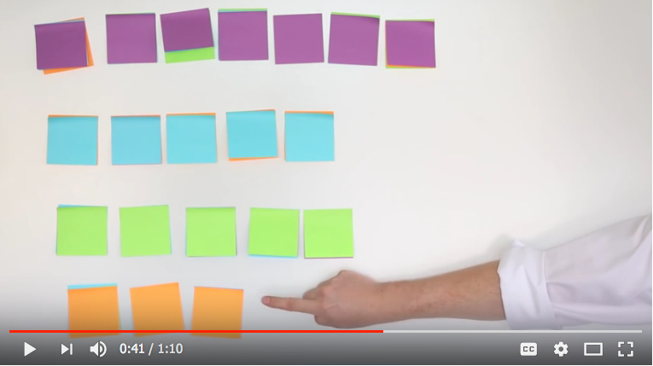
Hands-on games and shared treats make memories
of how each tool works. Next, simple simulations and national statistics show some the of high-level effects.
The effects on pages 54 through 59 are important for
the goverance of schools, clubs, towns and more. 47
C. SimElection Games

2. Watch Fair Rep Balancing a Council
These maps show RCV ballots electing five reps. A little shape is a voter’s ballot; a big one is a candidate. Each little ballot has the color and shape of its current
top-ranked choice, the closest remaining candidate.
1 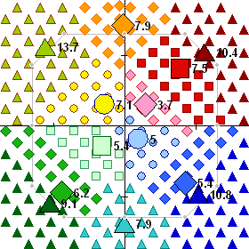
Sim players position candidates to get votes (page 56). The numbers on a map show each candidate’s current share of the votes; 16.7% will win a seat and a halo! After this round of counting, the weakest candidate must lose and get an X. The 3.7%  will be the first to lose.
To make close rivals distinct, colors vary from a spectrum. 48

The Weakest Lose, One at a Time
2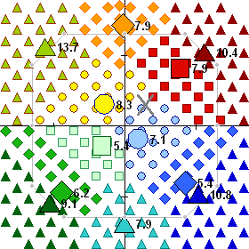 3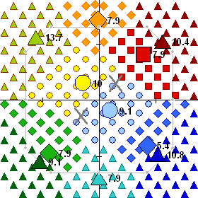
X
X
In map 2, the first loser gets an X. Her ballots change color and shape as each counts for its new top choice, a close rival. So the nearby fields of color grow.    (Game maps may portray places or political positions.*)
In 1, a gray line circles half the ballots. The candidates outside it lead their close rivals on the first ballot count. But in 2 and 3, as weak candidates lose, most of their ballots count for moderates or centrists inside that line.
4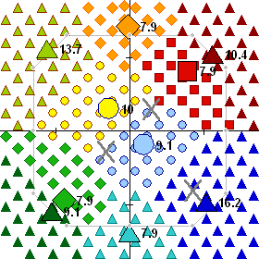 5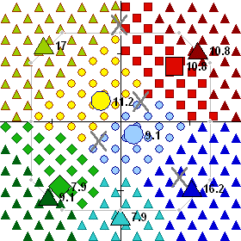
X
X
* Pages 10 and 13 introduced political dimensions. 49

Votes Transfer, Elect Reps
6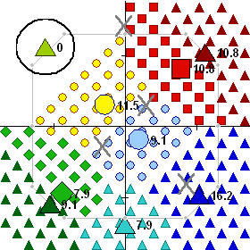 7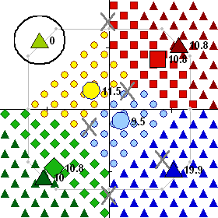
X
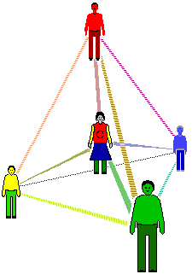
In 6, a candidate has just enough votes to win a seat. In 8, a winner has surplus votes; a fair share goes to each supporter’s next choice.   
The maps show only two issue dimensions.
But a five-seat council can form decisions
in 3D, if its reps are diverse. More issues
and positions get represented in campaigns
and debates, then in policies and projects—in 3D!
“RCV…gives you proportionality on every axis.”  □ 
8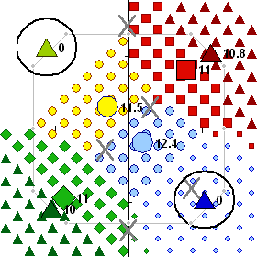 9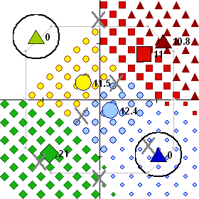
X
50

A Diverse and Balanced Council
10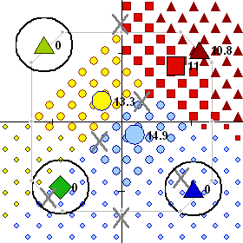 11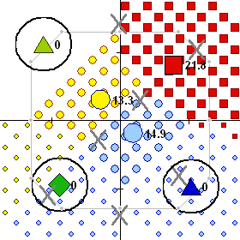
X
This pattern of voters makes their choices easy to see. SimElection™ also created uniform, random, custom and normal bell-curve patterns for games and research. To learn about life, play in lifelike normal patterns.
In 13, the box with half the ballots holds all but one rep. Does PRCV tend to favor and elect fringe candidates? Five reps together need what percentage of the votes? Are the reps diverse? Balanced fairly? Centered well?
12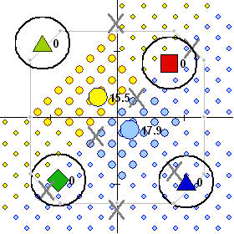 13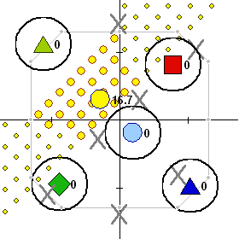
X
No. Over 83%. Yes. Yes. See page 55. 51

3. Simulation of Fair Share Voting
Fair Share Voting helps voters self organize many
ad hoc groups big enough to fund their favorite items. Each voter may try to help a few groups give money
or labor to one-time resource allocations, OTRAs, or maybe to optional items in some ongoing budgets; e.g.
FSV can choose repairs for roads but not new routes.
To find the best uses for our money,
hold Participatory Budgeting talks then
Fair Share Voting ballots and tallies.
This map shows the public plants proposed by voters on a campus. Often, the site closest to a voter is most useful to him and is his top choice. But this case has four distinct interest groups: Red, Yellow, Green, and Blue. Items can be close together on the map and yet be far apart in color. So this map shows a third issue dimension as deep layers of color within your screen.
This is a proposed blue-flower garden.
It is far from what the red voters want,
even if it is next door. A voter prefers
the closest item with his favorite color.
Here a garden club had $240 for public plants and each interest group got a quarter of the votes. So how much did each group allocate?
A red rosebush cost $30, two big sunflowers $15, an evergreen $20, a blue passionflower vine $60. A group with only a few, low-cost proposals might be able to fund them all. Did that happen here?
Answers: $60, $60, $60, $60. Yes for sunflowers. 52

Campus Map
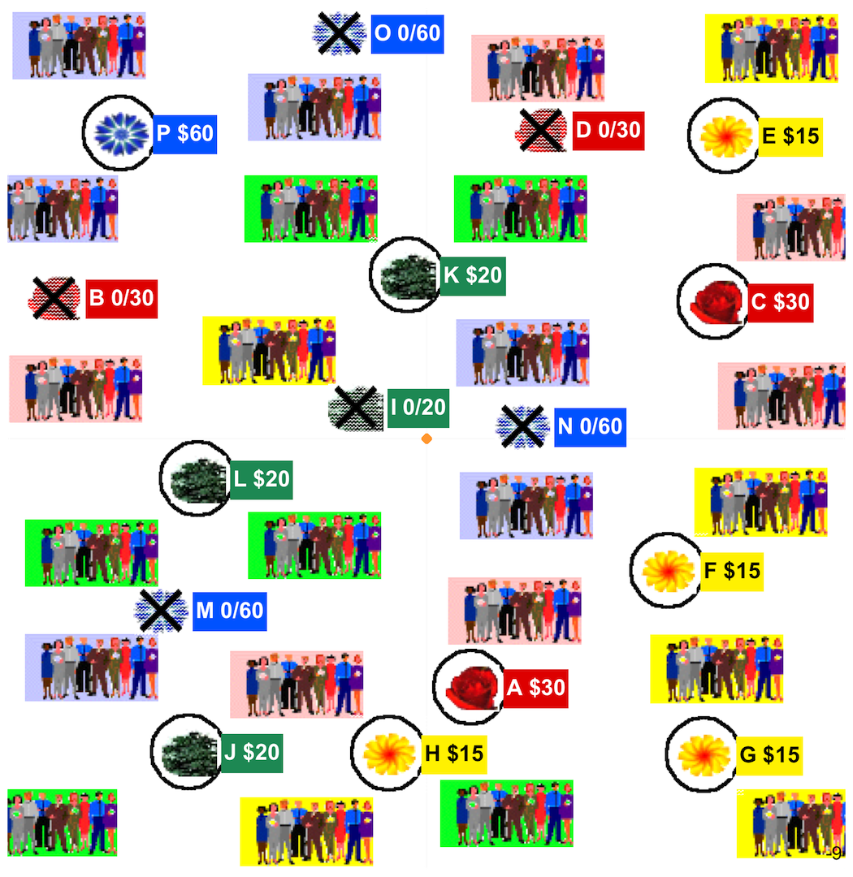
Any big group can focus or spread out their spending.
Loring Allocation Rule uses a Condorcet Tally to fund some items, then a Fair Share tally. The Condorcet Tally funds items with wide appeals to ad hoc majorities. It lets you vote for a sure winner without wasting any of your own power. Then the Fair Share tally funds items with narrower, more intense appeals. Elections too may tally Condorcet then fair-share winners. 53

Contrast 3 Councils, each with 5 seats
1. The Loring Ensemble Rule elects a few reps by
a Condorcet Tally, the rest by a PRCV tally; see page 8.
On this next map, a Condorcet Tally elects Al; then Fair Rep by four-seat PRCV elects Bev, Di, Fred and Joe.
The map shows each winner’s name in bold.
2. The Condorcet Series elects the candidates closest to the middle of the voters: Al, Bev, GG, Joe and Fred. The lower right or souteast gets no rep, so the council
is not well balanced. Each winner’s name is in italic.




3. Fair Rep by five-seat PRCV
elects Bev, Di, Fred, GG and Joe.
Each name is underlined.
It eliminated Al!

X

Notice Two Surprises
1. It may be surprising that broad Fair Rep helps the central Condorcet winner be the council’s swing voter. With these tools, political diversity can be a source of moderation as well as balance and a wide perspective.
2. Central reps can lead a broad Fair Rep council to broader majorities, holding moderates from all sides. This can add to or replace some of the “checks and
balances” used to moderate a council’s impacts.
54

Well Centered and Balanced
An Ensemble council combines
the breadth and balance of Fair Representation with the centering of Condorcet.
File Edit Window Organize Fund Campaign
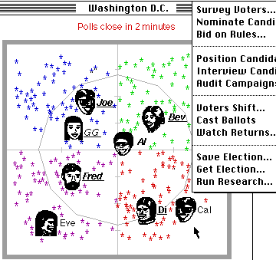
A council’s swing voter on an issue such as budgets or regulations, can strongly influence those decisions.
PRCV works to elect a balanced council with moderates and often a centrist. But it does not push any rep to
please a central majority of voters. Condorcet does. 
. 55

4. Watch Condorcet Find the Center
This map puts a line halfway between Al and a rival. Voters  on Al’s side of each line are closer to Al, so they rank Al over the rival. The long line has more voters on Al’s side than on Joe’s. So Al wins that test. Al wins a very different majority over each rival here. To do that, Al’s political positions must be central and have widespread support. page 31

In contrast, PRCV requires the most intense support, first-rank votes, to avoid early elimination.  page 48 RCV does too, with a high finish line of 50% + 1 vote. 56

↑ Back Matter

Voting Reform Is Cost Effective
Issue campaigns teach voters and reps for years. This eases one problem, but rarely fixes the source.
Election campaigns cost a lot all at once. The biggest faction can skew all policies for a few years.
Reform campaigns cost no more than elections. RCV strengthens reps and policies for many years.
Issue
Election
Reform
2022 2024 2026 2028
Campaign costs in green, results in yellow.
.

Strengthen Votes ∴ Mandates ∴ Policies
RCV expands the base of power, the numbers of effective votes and voters supporting: Pages
1. a CEO or a Chair from a plurality to a majority 14, 31
2. a Council from a plurality to over three quarters 21
3. the Budgets from a few power blocs to all voters 24
4. a Policy from a one-sided to an over-all majority. 30
Votes for real choices tally up real democratic power. It needs big mandates to govern new nondemocratic powers in big money, media, marketing and more. Mandates aid actions to achieve popular goals.
They build up a democracy and its leaders. 57

Voting Reforms Aid Related Reforms
Ballot access rules make it hard for small parties
to get on the ballot, because big parties fear “spoilers.” To calm that fear, let voters rank their backup choices. Ranked Choice Voting, RCV, opens up elections.

A news firm may serve us better if the subscribers steer more parts of it than investors or advertisers do. There’s a low-cost method for any membership group: Fair Share Voting can reward the best news bloggers.

Public campaign funding lets reps and rivals give less time to their sponsors, more time to their voters. One plan gives each voter $50 of vouchers to donate. Such nameless gifts or FSV can cut corrupt paybacks.
Big sponsors aim gifts to buy the few swing districts. RCV and Fair Representation make that harder.
So big business and billionaires may buy fewer seats.

“It’s very hard to see us fixing the climate until we fix our democracy.” —Dr. James Hansen

Good schools, taxes and voting may go together. Schools build our group skills and political know how.

Sabbatical terms make the current rep run against a former rep returning from rest, reflection, and research. Then the candidates include two with records in the job! Two alike do not break apart a group that uses RCV.

Citizens’ assemblies and their referendums can get more choices and control by using Condorcet Tallies. The laws on voting rules, reps’ pay, sponsors, etc. need referendums as all reps have conflicts of interest. 58

Civil Society Builds Democracy
Merchants and workers in medieval guilds won
some rights by building group skills, unity, and allies. Now local councils, co-ops and schools can build skills.
Empirical thinking grew in the Age of Enlightenment, leading to revolutions for human rights. Now rights must include Fair Representation and Fair Share Voting.
A big need for workers has often raised their pay and political strength, thus the political equality in a society. Now more progressive taxes can help political equality.

Move to a more democratic place (or .org)
To get good policies quickly, go where they are used. For example, do you want the democratic control and long-term savings of county or co-op owned utilities?
CEOs may need to be assertive, but not authoritarian. The latter corrupts commerce and wrecks human rights.
How can voting rules reduce the abuse of power?
Answers: RCV rivals act nicer. Swing-voting reps moderate.
Fair Rep and FSV spread power. So do the related reforms.
But a winner-takes-all tally starts a bad pattern. 59

Better Voting for Better Living
Data on the next page suggests, to elect reps who enact superb health, education, tax⁷ and other policies, a country needs effective, not wasted votes.
Does Fair Representation elect more women? p.18
Do they tend to raise health and education results?
Can these lift low incomes and reduce violent crime?
Do voter turnouts or seats won by women tend to be lower in countries with more: people? diversity? religion? polygamy? corruption? militarism? hot weather?! Are those harder to change than the voting rules?
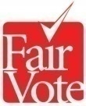


Data Definitions and Sources
Measures of respectable power and policies, circa 2016
Seats avg. per election district; Inter-Parliamentary Union
Women % of main legislature; Inter-Parliamentary Union
Turnout % Int’l. Inst. for Democracy and Electoral Assistance
Health Rank first is best; World Health Organization
Math Score Program for Int’l Student Assessment, OECD
Poverty % of children below half of median income; OECD
Murder Rate per million; 7th UN Survey of Crime Trends
Scores weighted by population give a voting rule’s average.
The table’s worst numbers are in bold. 60
Country Women Health Poverty%
Seats % Turnout Math Murder
Fair Rep page 16 | 37% | 75% | 15 | 503 | 13% | 12
Sweden 14 | 44 | 86 | 23 | 502 | 8 | 10
Finland 13 | 42 | 67 | 31 | 548 | 4 | 15
Spain 6.7 | 41 | 69 | 7 | 480 | 20 | 6
Norway 8.7 | 40 | 76 | 11 | 490 | 5 | 5
Belgium 8.4 | 39 | 89 | 21 | 520 | 13 | 16
Denmark 15 | 38 | 88 | 34 | 513 | 4 | 5
Netherlands 150 | 37 | 80 | 17 | 528 | 10 | 5
Austria 19 | 28 | 82 | 9 | 505 | 8 | 7
Switzerland 7.8 | 28 | 49 | 20 | 530 | 10 | 6
Costa Rica 21, 4 | 19 | 81 | 36 | 407 | - | 112
Uruguay 30, 2 | 13 | 90 | 65 | 409 | - | 111
Mixed, MMP p17 | 36% | 71% | 26 | 505 | 9% | 11
Germany 19, 1 | 39, 13 | 72 | 25 | 514 | 16 | 11
New Zealand 50, 1 | 45, 15 | 77 | 41 | 500 | 15 | 9
PRCV, RCV p42,14 | 34% | 89% | 29 | 517 | 14% | 11
Australia 6, 1 | 38, 25 | 93 | 32 | 520 | 15 | 10
Ireland 4 | 15 | 70 | 19 | 501 | 10 | 10
Runoff page 12 | 27% | 60% | 1 | 496 | 11% | 12
France 1 | 27 | 60 | 1 | 496 | 11 | 12
Plurality page 6 | 21% | 58% | 34 | 486 | 19% | 42
Canada 1 | 26 | 68 | 30 | 527 | 15 | 17
United Kingdom 1 | 29 | 66 | 18 | 495 | 10 | 12
USA 2020 2022 1 | 24, 25 | 60, 47 | 37 | 474 | 21 | 50
AccurateDemocracy.com/d_stats.htm will add
Corruption transparency.org, Democracy Index eiu.com,
Freedom freedomhouse.org, Purchasing power, Liesure.
U.S. turnout rises ~15% in presidential years. 61

Some Users and Endorsers
1. RCV elects leaders in more and more places: NYC, Portland, San Fran., Alaska and Maine have adopted it; plus Duke, Harvard, Princeton, Rice, Stanford, Tufts, MIT, Cal Tech, Carlton, Clark, GWU, Reed, Vassar, the Universities of CA, Houston, IA, IL, MA, MN, NC, OK, TX, VA, WA, & WY.
2. Multi-Winner RCV users include Australian and Irish voters in local and national elections, the Church of England, Cambridge U., Carnegie Mellon, Clark, MIT, Oberlin, Oxford, UC Cal, UC Davis, UCLA, UCSB, UT Austin, Vassar, and many more www.fairvote.org/rcv_in_campus_elections
Many groups endorse ranked choice voting.
Celebrities: Krist Novoselic, Jennifer Lawrence 6/5/2018, John Cleese, Dr. James Hansen, and more
Journalists: David Brooks 6/1/2018, Hendrik Hertzberg,
Leagues of Women Voters: Arizona, California, Florida, Maine Massachusetts, Minnesota, North Carolina, Oklahoma, Oregon, South Carolina, Vermont, and Washington.
National Newspapers: New York Times Sunday 6/10/18, USA Today, Washington Post 6/14/18; Recent regional editorials: Portland Press Herald, Las Cruces Sun News…
Organizations: The Academy Awards (Oscars), AAAS, Common Cause, Sierra Club, UUA; for more see link below.
Parties: Democrats of CA, CO, MA, and ME; Green Party US Libertarian Party, Republicans of Alaska, UT, VA, and more
US Reps: Keith Ellison, Jamie Raskin, Don Beyer, and more
US Senators: McCain, Obama, Sanders, and more
http://www.fairvote.org/ranked_choice_voting_endorsements
fairvote.org/rcv_in_private_organizations_and_corporations 62

About Us
 is a nonpartisan champion of electoral reforms that give voters greater choice, a stronger voice, and a democracy that works for all Americans.
It has a proven record since 1992 as a trailblazer
that advances and wins electoral reforms at the local, state, and national levels through strategic research, communications and collaboration. Today it is the driving force for advancing ranked choice voting and fair representation in multi-winner districts that will open up our elections to better choices, fairer representation and more civil campaigns for better government.

About My Work
In 1990, John R. Chamberlin and Samuel Merrill III encouraged me to use their research, noted on page 63, to support a hybrid Condorcet-RCV tally. (See page 30.) In the 1990s, I coded PoliticalSim™ and SimElection™.
They compared 30 single- and multi-winner tallies from around the world and were used in a few universities. Pages 48-56 show graphics from the simulation games. My sim research led to Democracy Evolves in 1997. Then I helped FairVote as a webmaster and librarian. For 10 years, I cheered Twin Oaks Community as they tested new uses for Fair Share Voting. (pages 24, 43) This ebook summarizes AccurateDemocracy.com
My goals are better group-decision results (page 61), through systemic changes (pages 34, 58), through
better tools between people (pages 24+, 30+, 35).
63

Copyrights
N€w N¥w
New Tools
N₤w N$w
\ /
We feel this information should be free.
So we give it a Creative Commons License,
make this ebook free and print a few $10 copies.
\ /
Please let others share this to improve
voting in your clubs, college, city and state.
What will you do or give to live in a more
educated and accurate democracy?
Consider helping FairVote.org
| |
Photo credits: cover Rawpixel,
page 5 Kiichiro Sato, page 47 Minnesota
Public Radio, page 38 Mercedes-Benz,
page 59 Flickr pool, Local Living Venture.
Others not attributed. All photos altered.
| |
© CC BY-SA 3.0 2023, Robert Loring
AccurateDemocracy and its logo are trademarks.
We encourage reviews, reprints and translations.
ISBN 9978-1-7362637-2-3
/ \
Kindly send any requests, questions,
comments or compliments to me at

Some Questions to Ask
Some basic questions to ask about any voting rule: Has any group used it repeatedly over several years?
How consequential and competitive was their voting?
What were the percentages of turnouts and of wasted votes?
What incentives does it give to voters and leaders?
Is its pattern of winners erratic or consistent over the years?
If it is consistent, is the pattern fair shares or winner takes all?
If winner takes all, is the winner from one side or the center?
If it is from the center, is the winner’s appeal wide or narrow?
How often was it manipulated by a gerrymander, a “spoiler,” a stacked agenda, strategic voting, or other rigged votes?
Some basic questions to ask about voting-rule research: Are the data from: 1) Real competitions, 2) Computer sims with: A) normal distributions of voters and candidates B) weird distributions, 3) Concocted examples, 4) Mathematical proofs. Only the first really includes human psychology. Most sources cited here use real data or realistic simulations. Other kinds of data risk “garbage in, garbage out” and may be fascinating mathematically but misleading in real-life.
Manipulation is best resisted by Condorcet-RCV hybrids. They’re even better than the usual RCV.^{4.2} Any decisive,
non-dictatorial voting rule can be manipulated sometimes.
So the operant questions are, 1) “How often can each rule be manipulated in a realistic electorate?” 2) “How easy is the manipulation?” and 3) “How damaging is its effect?”
Why do this work? To help the most people, give them tools to make better group decisions, to allocate resources and to reduce conflicts, page 35. The multiplier effect is huge as
a small budget for voting can steer much bigger budgets.
So, many schools, clubs and towns are adopting RCV.
65

Endnotes by Chapter For each chapter, the endnote numbers restart at one. Good pdf viewers let you click on each entry’s Web link. I abbreviate and format as needed to fit the page width. I favor online sources that use data from real elections or realistic sims. This is essential for realistic research. This is the first book about Ensemble Councils, Fair Share Voting and rules of order for Condorcet policies It covers some AccurateDemocracy.com (ⓐ) pages including a_primer.htm a_workshop.htm d_stats.htm. The website has free apps z_tools.htm, animations d_stv2d.htm or p_tools.htm, and Web links z_bib.htm FairVote.org has model ballots and bylaws, stories, analysis, an activist_toolkit, videos and more. I. Introduction, Tragedies, and Progress + American Accademy of Arts and Sciences. Our Common Purpose, American Democracy for the 21st Century. + Andres Braun y Alejandro Cabrera. Nosotros la Gente. (Cordoba: El Emporio Editions, 2021) English ed. Argentina Has a Solution. + Katherine M. Gehl and Michael E. Porter. “Why Competition in the Politics Industry is Failing America;” Harvard Business Sch. 9/2017 https://www.hbs.edu/competitiveness/Documents/why-competition-in-the-politics-industry-is-failing-america.pdf ? Amy, Douglas J. Proportional Representation: The Case for a Better Election System. North Carolina is on page 30; http://archive.fairvote.org/?page=1606
Durbin, Kathy. Tree Huggers: Victory, Defeat & Renewal in the Northwest Ancient Forest Campaign, (Seattle, The Mountaineers, ‘96)
Hoag, Clarence. and George Hallett, Proportional Representation, (New York City, The Macmillan Company, 1926).
Duverger, Maurice. "Factors in a Two-Party and Multiparty System," Party Politics and Pressure Groups (New York City: Thomas Y. Crowell, 1972), pages 23-32. Rein Taagepera, and Mathew Soberg Shugart. Seats and Votes: the Effects and Determinants of Electoral Systems. New Haven: Yale University Press, 1989.
FairVote, Monopoly Politics, fairvote.org/monopoly_politics_2020
Lijphart, Arend. Electoral Systems and Party Systems: A Study of Twenty-Seven Democracies (Oxford University Press, 1994).
See pages 30, 31, and 54-56.
The statistics on pages 60-61 compare ninteen stable democracies. 66
1. Electing a Leader, Ranked Choice Voting ⓐ c_irv.htm ? Chamberlin, John R.; Jerry L. Cohen and Clyde H. Coombs; "Social Choice Observed: Five Presidential Elections of the American Psychological Association" Journal of Politics. 46 (1984) 479-502 "An Investigation into the Relative Manipulability of Four Voting Systems", Behavioral Science; 30:4 (1985) 195-203. Merrill, Samuel III. Making Multi-candidate Elections More Democratic. (Princeton, NJ: Princeton University Press, 1988).
The Editorial Board. “The Primaries Are Just Dumb.” nytimes.com/2020/02/26/opinion/democrats-primary-south-carolina.html.
Ranked Choice Voting Civility Project fairvote.org/rcv_civility_project/ Reilly, Benjamin. Democracy in Divided Societies: Electoral Engineer-ing for Conflict Management, (Cambridge University Press 2001). nytimes.com/2021/02/25/opinion/elections-politics-extremists.html
Ranked Choice Voting Civility Project fairvote.org/rcv_civility_project/ Reilly, Benjamin. Democracy in Divided Societies: Electoral Engineer-ing for Conflict Management, (Cambridge University Press 2001). nytimes.com/2021/02/25/opinion/elections-politics-extremists.html
Wright, Stephen G. “Voter Turnout in Runoff Elections”, The Journal of Politics, Vol. 51, No. 2 (May, 1989), pages 385-396. “Ranked Choice Voting outperforms runoffs in upholding majority rule” Rob Richie, Madeline Brown. (FairVote, 2017).
Korean election http://en.wikipedia.org/wiki/Roh_Tae-woo https://web.archive.org/web/20010113205900/http://nimbus.ocis.temple.edu/~jhurewit/history.html
Papua New Guinea: Electoral Incentives for Inter-Ethnic Accommodation, http://aceproject.org/ace-en/topics/es/esy/esy_pg Chau, Amy and Rubenfeld, Jed. “The Threat of Tribalism” https://www.theatlantic.com/magazine/archive/2018/10/the-threat-of-tribalism/568342/
RepresentWomen.org/representation_and_rcv_a_long_term_solution
2. Electing Representatives, Fair Rep ⓐ d_intro.htm ? and 7 Statistics on page 60-61 compare democracies. d_stats.htm
Huber, John D. and G. Bingham Powell, Jr., “Congruence Between Citizens and Policymakers in Two Visions of Liberal Democracy,” World Politics vol. 46 #3 (April 1994), pages 291-326.
“Illinois Assembly on Political Representation and Alternative Electoral Systems”, (IGPA University of Illinois, Spring 2001) http://www.fairvote.org/media/pep/execsum.pdf History of cumulative voting, 1870-1970: Three is better than one http://www.lib.niu.edu/1982/iisr04.html fairvote.org/monopoly_politics_2020 http://archive.fairvote.org/index.php?page=39&articlemode=showspecific&showarticle=1325 67
Roberts, Nigel. NEW ZEALAND: A Long-Established Westminster Democracy Switches to PR, (Stockholm, IDEA) www.nigel-roberts.info/NSR-in-Reynolds-&-Reilly-1997.pdf.
Mathews, Dylan. “3 Reasons New Zealand has the Best Designed Government in the World” vox.com, Jan. 16, 2015. Shugart, Mathew Soberg. Emergency Electoral Reform: OLPR for the US House. fruitsandvotes.wordpress.com Jan. 2021. Santucci, Jack. A Modest and Timely Proposal. www.voteguy.com/2020/12/09/a-modest-and-timely-proposal/
Richie, Rob and Andrew Spenser; “The Right Choice for Elections” University of Richmond Law Review; v. 47 #3, March 2013. https://lawreview.richmond.edu/files/2013/03/Richie-473.pdf
Krook, Mona Lena. Quotas for Women in Politics: Gender and Candidate Selection Reform Worldwide; (Oxford U Press, 2009), 123. Healy, Andrew and Jennifer Pate. “Can Teams Help to Close the Gender Competition Gap?” Economics Journal, 121: 1192-1204 https://web.archive.org/web/20170706034311/http://myweb.lmu.edu/ahealy/papers/healy_pate_2011.pdf
http://www.nytimes.com/2016/11/10/upshot/women-actually-do-govern-differently.html Statistics of Nations. ⓐ d_stats.htm www.nytimes.com/2020/05/15/world/coronavirus-women-leaders.html
3. Allocating Budgets, Fair Share Voting ⓐ p_intro.htm FSV=PRCV if $# = voters#, 1 share = $1, and 1 seat costs $# / (seats+1) ? Shah, Anwar ed., Participatory Budgeting; The World Bank Washington, DC; http://siteresources.worldbank.org/PSGLP/ Resources/ParticipatoryBudgeting.pdf
Moore, Joe Participatory Budgeting in the 49th Ward, http://participatorybudgeting49.wordpress.com/ In 2014 voters in Cambridge, Massachusetts saw the same pattern.
Tupelo-Schneck, Robert and Robert B Loring, Fair Share Voting, Proposing a New Voting Method for Participatory Budgeting, 2012; ⓐ download/workshop/fair-share-spending.pdf .ppt and .odp . ⓐ download/workshop/gasto-equitativo.pdf .ppt and .odp .
News of the Oaks, Leaves of Twin Oaks, Louisa, VA 1995
Oaks, Adder. “Participatory Budgeting in an Income Sharing Com-munity;” Communities: Life in Cooperative Culture; #175, 6/2017. ic.org/participatory-budgeting-in-an-income-sharing-community/ Leaves of Twin Oaks, 2013. To cut a budget level needed support from 55% of the voters; so no one tried to protest a cut. + If an FSV tally leaves too many “exhausted ballots,” with money but no items, maybe reduce the required base number of voters. + Lani Guinier at Harvard Law, www.youtu.be/eVsTpjSsGBQ?t=3177 + pbstanford.org/dieppe2015/ranking participatorybudgeting.org 68
4. Enacting a Policy Condorcet Tally ⓐ l_intro.htm ? Chamberlin et al above, also Merrill. ⓐ c_data.htm ⓐ l_data.htm If A tops B, B tops C, and C tops A, we have a “voting cycle.” Tally IRV with the motions in the top voting cycle. ⓐ l_cycles.htm
Green-Armytage, James. "Four Condorcet-Hare Hybrid Methods for single-winner elections"; votingmatters.org.uk/ISSUE29/I29P1.pdf "Strategic Voting and Nomination"; Social Choice and Welfare; 2014 Tideman, Nicolaus. Collective Decisions and Voting; (Ashgate Publishing Ltd., Hampshire, England; 2006) page 232. Green-Armytage, Tideman and Rafael Cosman, "Statistical Evalu-ation of Voting Rules" Social Choice and Welfare; 2016, 46: 183. Loring, Robert. Loring One-winner Rule (LOR); 1996 ⓐ c_data.htm https://www.accuratedemocracy.com/l_lor1.htm. Hill, I.D. “Some Aspects of Elections--To Fill One Seat or Many” Journal of the Royal Statistical Society. Series A. Vol. 151, No. 2 (1988), pp. 243-275 https://doi.org/10.2307/2982757
See the captions on pages 15 and 56. ⓐ c_irv.htm#compare
https://en.wikipedia.org/wiki/Primary_challenge
https://www.nytimes.com/interactive/2018/11/10/opinion/house-representatives-size-multi-member.html
https://www.accuratedemocracy.com/l_motion.htm .
Social Effects of Group Decision Tools ? Bennett-Smith, Meredith. World's Happiest Countries 2013, http://www.huffingtonpost.com/2013/05/28/worlds-happiest-countries-2013-australia_n_3347347.html; Cites UN, OECD. OECD Better Life Index http://www.oecdbetterlifeindex.org Rothstein B. and, E. Uslaner. All for All: Equality, Corruption, and Social Trust; World Politics, Vol. 58, #1, October 2005: 41-72 https://projects.iq.harvard.edu/gov2126/files/rothstein_2005.pdf
Susskind, Lawrence and Jeffery L. Cruikshank; Breaking Robert’s Rules; (Oxford University Press, 2006). Francis, Fred and Peg Democratic Rules of Order, 2010. pp 19, 24. LiquidFeedback.org Free software to help groups make decisions. Christian, Diana Leafe “Radical Governance Changes in Two North American Ecovillages”, IC.org 08/31/2014.
3 Group-Process Pattern Language, www.groupworksdeck.org.
Accurate Democracy motions for Condorcet ⓐ l_motion.htm https://en.wikipedia.org/wiki/Committee_of_the_whole 69
B. Workshop Games, hold a vote ⓐ a_workshop.htm ? A voter’s ranks may skip around, e.g. 1st left, 2nd far right, 3rd center
Loring, Robert. “A Simple Tally Method,” ⓐ p_tally.htm#tech
FairVote, Ranked Voting and Questions About Election Integrity, Published October 12, 2013. http://www.fairvote.org/ranked-voting-and-questions-about-election-integrity/ www8.nationalacademies.org/onpinews/newsitem.aspx?RecordID=25120 Election Audits http://electionaudits.org/ http://verifiedvoting.org
Portland Voters Overwhelmingly Support Ranked Choice Voting; FairVote, 2015.
Krosnick, Jon A. "In the Voting Booth, Bias Starts at the Top", New York Times, nytimes.com/2006/11/04/opinion/04krosnick.html?_r=0
https://accuratedemocracy.com/a_teach.htm
Workshop Video 1, youtube.com/watch?v=oHRPMJmzBBw Workshop Video 2. youtube.com/watch?v=_5SLQXNpzsk + https://www.fairvote.org/rcv_ballot_design + A ballot by the inventor of FSV http://tupelo-schneck.org:8080/tag/
C. Simulations, compare, ⓐ d_stv2d.htm, p_tools.htm
1 Loring, Robert, SimElectionTM 1996, http://www.simelection.com ? Lorence, Stella; “Massachuesetts Voters May Face Ranked Choice Voting Question On November Ballot”. 3/3/2020 BU News Service. quoting Moon Duchin, MGGG Redistricting Lab, Tufts University.
See entries above for Robert Loring; or John R. Chamberlin et al; or Samuel Merrill III; or James Green-Armytage. 99 Brady, Henry E. "Dimensional Analysis of Ranking Data", American Journal of Political Science. 34 (11/90)
Back Matter, compare rules, ⓐ z_review.htm, ? https://en.wikipedia.org/wiki/Democracy_voucher Ackerman, Bruce and Ian Ayres, Voting with Dollars: A New Paradigm for Campaign Finance; (New Haven: Yale Univ. Press, 2002).
Gifts to “spoilers” are less effective under Ranked Choice Voting. Multi winner districts make it hard to target money on just one seat.
https://www.nytimes.com/2018/06/223/opinion/Sunday/james-e-hansen-climate-global-warming.html See also, “conservation ... depends on effective governance;” https://www.nature.com/articles/nature25139.
Compare the math scores on, pages 60-61. ⓐ d_stats.htm 70
Chalmers, Patrick. “The People Trying to Save Democracy from Itself”, http:// theguardian.com/world/2016/jul/02/democracy-tarnished-brand-desperate-need-reinvention. Bouricius, Terrill G. Democracy Through Multi-Body Sortition: Athenian Lessons for the Modern Day”, New Democracy Institute, Journal of Public Deliberation, Vol.9 #1; 04/30/13. Navajas, Joaquin et al; “Aggregated knowledge from a small number of debates outperforms the wisdom of large crowds,” Cornell University, 2017. https://arxiv.org/abs/1703.00045
Tishman, Shari and Albert Andrade; Thinking Dispositions, https://pdfs.semanticscholar.org/57cb/278acf38e9da6490d266260f9a9c50d20da3.pdf Many people use these ways of thinking at times. But fewer have a disposition to use them routinely. http://learnweb.harvard.edu/alps/thinking/docs/dispositions.htm
See progressive taxes in Wikipedia pages on Carbon_tax, Consumption_tax#Expenditure_tax, Land (Georgism), Speculation (Financial_transaction_tax), and Wealth_tax. Piketty, Thomas and Arthur Goldhammer; Capital in the 21st Century, Cambridge MA: Belknap Press of Harvard University Press, 2014.
https://cyber.harvard.edu/publications/2018/01/communityfiber Institute for Local Self-Reliance http://www.ilsr.org/ On Solar Streets and Wilderness Alleys windsong.bc.ca
Loring, Robert; “Egalitarian versus Authoritarian Values” https://accuratedemocracy.com/a_quotes.htm#egal https://scholar.princeton.edu/sites/default/files/mgilens/files/gilens_and_page_2014_-testing_theories_of_american_politics.doc.pdf
Taub, Amanda; https://psypost.org/2018/06/study-finds-less-corruption-countries-women-government-51530 “Why Are Women-Led Nations Doing Better with Covid-19?”, New York Times, May 15, 2020 nytimes.com/2020/05/15/world/coronavirus-women-leaders.html
Damien Cave. “Jacinda Ardern Sold a Drastic Lockdown With Straight Talk and Mom Jokes”. nytimes.com/2020/05/23/world/asia/jacinda-ardern-coronavirus-new-zealand.html Defines MMP. ? https://www.fairvote.org/rcv_in_campus_elections https://www.fairvote.org/where_is_ranked_choice_voting_used
https://web.archive.org/web/19990218104532/http://members.aol.com/loringrbt/elect.htm https://web.archive.org/web/1999102301124/http:/members.aol.com:80/loringrbt/a_intro.htm Back Cover, See page 62. 71 Resources, for education and action AccurateDemocracy.com, gives you free software, animations of PRCV or Fair Share Voting, and pages on each voting tool, ⓐ a_primer.htm, ⓐ a_workshop.htm, d_stats.htm, SimElection.com, and references z_bib.htm eBook AccurateDemocracy.com/AcDem.pdf .org is a nonpartisan catalyst for electoral reforms. It is the best source for news, analysis and resources about voting reform in U.S. cities, states and colleges. It gives you model ballots, bylaws, editorials, research reports, voter education flyers, testimonials and videos. Ranked Choice Voting Resource Center. Kindly send any requests, questions, comments or compliments to me at 72 Glossary and Index Accurate democracy gives fair shares of seats and spending. It cuts scams and enacts a policy that tops all rivals. 4 goals a Mandate is the authority effective votes loan to a Pages winner. It is a basic goal. Contrast a wasted vote. 11-17, 57 a Majority is more than half of the votes. 11, 14, 30-, 56 a Plurality option has the most votes – often not a majority. " rules use yes-or-no voting; contrast RCV. 6, 11, 23, 31-, 61 a Ranked Choice Vote lets you rank a 1st choice and backups. It is a tool for effective votes and fair shares. 14-, 33, 45 a Voting Rule (system, tally, tool) has a ballot, tally steps and a level of support needed for a win. 6, 14, 17, 24, 30, 42- a Wasted vote for a loser, winner’s surplus or a powerless rep It discourages voting and weakens democracy. 12-18, 23, 27 a Wrecking amendment ruins a bill’s chances or effects. a Free-rider " doesn’t relate to the original bill. 30, 33, 34 See also the Summary and Index of Benefits on page 34. Acronyms and Synonyms Pages Consensus process 33, 36- CT, Condorcet Tally, Pairwise Comparison 28-30-, 44, 54-56 EC, Ensemble Council: CT plus FR New 8-, 31, 54-55 FR, Fair Rep, Fair Representation (US); PR, Proportional Representation. (See PRCV, STV below) 7, 16-18-, 61 MMP, Mixed-Member Proportional 19-20, 55 FSV, Fair Share Voting New 22-24-, 36-, 43, 46, 52- RCV, Ranked Choice Voting: STV, Single Transferable Vote, PRCV, Proportional RCV (US) for Fair Rep 42, 48-51, 54 IRV Instant Runoff Vote (US) Majority Preferential Vote (Aus) AV, Alternative Vote (UK) or Hare for SMD 14-, 39-42, 56 SMD, a Single-Member District elects one rep ............6, 16, 19

