A Balanced Council  We arranged the voters here in a checkerboard.  This simple pattern makes it easy to see transfers. PoliticalSim is used more often to create uniform, random and normal distributions. Players then move their candidates, seeking the best positions for whichever voting rule is in play.  Choice Voting elects a well balanced council.  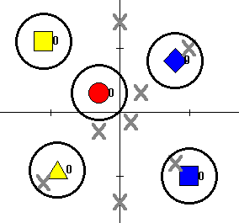  4 |  | See Choice Voting Balance a Council  Here are 14 scatter charts from PoliticalSim. They show simulated voters as small dots and candidates as big ones. Losers get an X and winners get a halo.  A voter's dot has the same color and shape as his current top preference - the closest candidate. A voter's dot will disappear as his vote, or “weight,” is used to elect his rep(s). The number beside a candidate shows her current percentage of the votes.  These 13 candidates and 241 voters condense into 5 reps in 14 steps. In steps 1 through 7, no one gets a quota of ballots, so after each count, we drop the weakest candidate; that’s the 1 with the fewest votes.  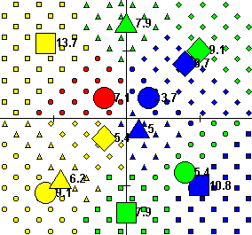  1
Votes Move From Weak Candidates  Votes move from a loser to the voter's next choice.  2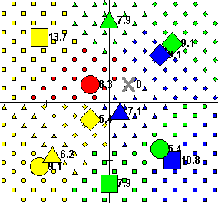 3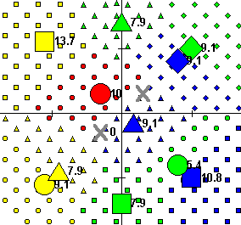  4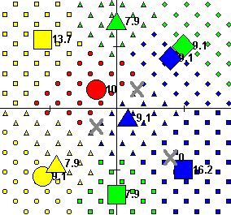 5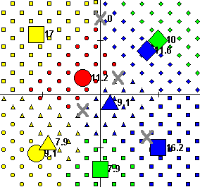  6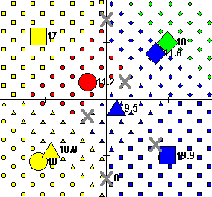 7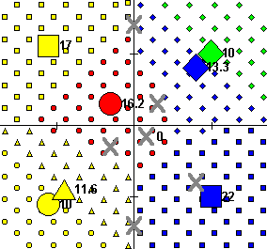  2 |  | Losers Lead To Winners  Votes moving from a loser help a similar candidate win.  8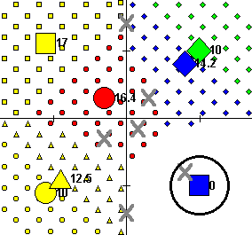 9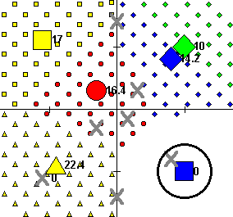  10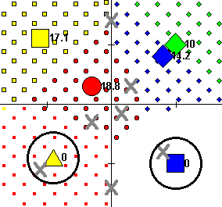 11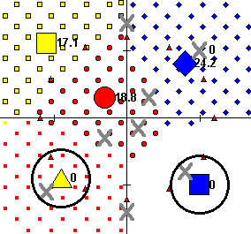  12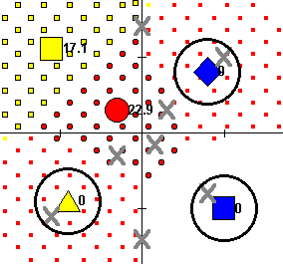 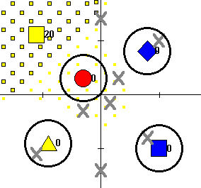  3

Votes Move From Weak Candidates  Votes move from a loser to the voter's next choice.  2 3  4 5  6 7  2 |  | Losers Lead To Winners  Votes moving from a loser help a similar candidate win.  8 9  10 11  12  3
A Balanced Council  We arranged the voters here in a checkerboard.  This simple pattern makes it easy to see transfers. PoliticalSim is used more often to create uniform, random and normal distributions. Players then move their candidates, seeking the best positions for whichever voting rule is in play.  Choice Voting produces a well balanced council.  4 |  | See Choice Voting Balance a Council  Here are 14 scatter charts from PoliticalSim. They show simulated voters as small dots and candidates as big ones. Losers get an X and winners get a halo.  A voter's dot has the same color and shape as his current top preference - the closest candidate. A voter's dot will disappear as his vote, or “weight,” is used to elect his rep(s). The number beside a candidate shows her current percentage of the votes.  These 13 candidates and 241 voters condense into 5 reps in 14 steps. In steps 1 through 7, no one gets a quota of ballots, so after each count, we drop the weakest candidate; that’s the 1 with the fewest votes.  1

